

ASSIGNMENT

**LEVEL 5**

**COMP50022 : Server Side Programming 2**

IF23A1SE_IF2421SE

Hand Out Date: 18th March 2024

Name: Chirath Sanduwara Wijesinghe

ID: CB011568

**INSTRUCTION TO CANDIDATES**

1. **Late submission will be awarded zero (0) unless extenuating circumstances (EC) are upheld.**
2. **Cases of plagiarism will be penalized.**
3. **The assignment should be submitted as softcopy via LMS**
4. **All evidences related to the sprint implementation in group assignment must be show cased in the final documentation.**

Table of Contents

Acknowledgment 4

Introduction 4

System Objectives 5

System Architecture 6

Backend Architecture 6

Frontend Architecture 9

Entity-Relationship Diagram of the website 11

System Features 14

Screenshots of the website 18

Mail-trap Screenshots 55

Screenshots of the code & Postman testing (requests) 56

Test Cases 67

Assumptions 69

Future Upgrade Plan 69

Expanding as a Saas Solution 71

Figure 1 10

Figure 2 10

Figure 3 11

Figure 4 19

Figure 5 20

Figure 6 20

Figure 7 21

Figure 8 22

Figure 9 22

Figure 10 23

Figure 11 23

Figure 12 24

Figure 13 25

Figure 14 26

Figure 15 26

Figure 16 27

Figure 17 28

Figure 18 29

Figure 19 30

Figure 20 31

Figure 21 31

Figure 22 32

Figure 23 32

Figure 24 32

Figure 25 33

Figure 26 33

Figure 27 34

Figure 28 35

Figure 29 36

Figure 30 36

Figure 31 36

Figure 32 37

Figure 33 37

Figure 34 38

Figure 35 38

Figure 36 39

Figure 37 39

Figure 38 40

Figure 39 40

Figure 40 41

Figure 41 42

Figure 42 42

Figure 43 42

Figure 44 43

Figure 45 44

Figure 46 44

Figure 47 44

Figure 48 45

Figure 49 45

Figure 50 46

Figure 51 46

Figure 52 47

Figure 53 47

Figure 54 48

Figure 55 48

Figure 56 49

Figure 57 50

Figure 58 50

Figure 59 50

Figure 60 50

Figure 61 51

Figure 62 51

Figure 63 52

Figure 64 53

Figure 65 53

Figure 66 53

Figure 67 53

Figure 68 54

Figure 69 55

Figure 70 56

Figure 71 56

Figure 72 57

Figure 73 57

Figure 74 58

Figure 75 58

Figure 76 59

Figure 77 59

Figure 78 60

Figure 79 60

Figure 80 61

Figure 81 62

Figure 82 62

Figure 83 63

Figure 84 63

Figure 85 64

Figure 86 65

Figure 87 66

Figure 88 67

Figure 89 67

Figure 90 67

Figure 91 67

# Acknowledgment

I would like to take this opportunity to express my sincere gratitude to our lecturer, Mr. Vipula Anandapiya, for his invaluable guidance throughout our coursework. His continuous encouragement and support have inspired us to think creatively and approach our work with innovation. We are truly thankful for his dedication and the knowledge he has imparted, which has significantly contributed to our learning experience.

Introduction  
  
This documentation provides a comprehensive overview of the system I have developed for **Cloth-X**, a dynamic e-commerce platform that primarily focuses on clothing but also offers a variety of electronic products. The Cloth-X system is designed to manage product listings, handle customer orders, maintain user information, and facilitate seamless communication between customers and vendors.

Key features include inventory management, sales tracking, user authentication, vendor management, and order processing. The system also includes a powerful admin dashboard, where administrators have full control over the frontend and the entire website. Through the dashboard, admins can manage products, update content, oversee users, and handle orders using intuitive CRUD operations. This allows all aspects of the site to be dynamically updated and modified without altering the underlying code.

Additionally, upon completion of each order, an automatic email notification is sent to the customer confirming the dispatch, along with the relevant order details, using Mailtrap for email testing. This document outlines the objectives, features, and architecture of the Cloth-X system, concluding with a system presentation and relevant screenshots to provide a clear understanding of its functionality.  
  
Link to the Mind Map : <https://gitmind.com/app/docs/m6xufr9o>

Link to the GitHub Repo : <https://github.com/ChizzyDizzy/ClothX-Ecommerce-Laravel>

System Objectives  
  
Main Goals of this system

**Optimize Inventory management:** Implement an efficient inventory/stock management system to keep track of the orders of the customers ensuring the highest customer satisfaction. Implement real time tracking of the products as well.

**Streamline Delivery:** Delivering the customers requested products to their desired location

**Enhance Customer Engagement:** Enhance Customer Engagement with flash sales, flash deals, coupons to redeem like any usual ecommerce site would have  
  
**Implement dashboards to control the website:** Implement admin dashboard and vendor dashboard and another dashboard for the user, allow the admin to control the website’s frontend with ease using the dashboard dynamically with crud operations  
  
**Track Sales:** Generate statistics of sales data with Admin and Vendor dashboards to keep track of the products in a more organized manner  
  
**Gather customer purchase and order data:** Make sure the admin and the vendor can see details about the purchases that came from the products that they listed  
  
**User Authentication:** Implement robust user authentication with validations for all three types of users  
  
**Dynamically active:** Make the website dynamic as possible to control the frontend with ease using the website itself in Realtime  
 **Chat System:** Implement a chat system to increase customer engagement between the admin and the vendor’s allowing a more robust CRM model to be implemented  
Target Audience  
  
The target audience of this project is the general public and it will have its focus primarily on three types of user (normal user, vendor, admin) with each of those users having their own dashboard for ease of access.

# System Architecture

## Backend Architecture

The backend of the Cloth-X website is built using Vanilla Laravel, offering a flexible and powerful system for managing business logic, data, and user interactions. By leveraging Laravel’s core MVC (Model-View-Controller) structure, jQuery DataTables, JavaScript, and MySQL, the backend efficiently handles CRUD operations, while Toastr.js is used for custom notification and validation feedback, enhancing user experience.

**Vanilla Laravel Framework (Without Breeze or Jetstream):**

The Cloth-X backend is developed using Vanilla Laravel, excluding starter kits like Breeze or Jetstream. This allows for a more tailored and custom approach to handling routing, authentication, and database operations. Laravel’s modular architecture ensures a clean and maintainable codebase, with all dynamic content and logic handled through controllers and Eloquent models.

Laravel’s routing system directs incoming HTTP requests to appropriate controllers, handling the application logic for product management, user accounts, and order processing.

**MySQL Database (Powered by Laragon):**

MySQL is used to manage all relational data for the website, including products, users, orders, vendors, and transactions. Laravel’s Eloquent ORM (Object-Relational Mapping) handles all database queries in an efficient manner, translating PHP objects into MySQL records, eliminating the need for raw SQL.

Laragon provides an easy-to-use local development environment, streamlining database management during development, and enabling seamless connection to MySQL with minimal setup.

**CRUD Operations:**

Laravel powers the backend CRUD (Create, Read, Update, Delete) operations, managing all key aspects of the e-commerce platform, such as adding, editing, and removing products, managing user accounts, and handling customer orders. These operations are tightly integrated with the frontend using Laravel’s built-in routing and form handling.

Each action, whether updating a product or managing orders, is handled by Laravel controllers that interact with Eloquent models to perform efficient database operations.

**Toastr.js Custom Validations:**

Toastr.js is integrated into the backend to provide custom real-time notifications for validation errors and success messages. This offers a more user-friendly experience with clear visual feedback, informing users of successful actions (e.g., product added successfully) or errors (e.g., invalid input).

Toastr.js provides non-intrusive pop-up notifications, making it easier for admins and users to interact with forms and data operations without page reloads.

Default Laravel validations are still used in the backend to ensure that the data submitted by users complies with defined rules (e.g., required fields, valid email formats). However, instead of Laravel’s default error messages being shown on the page, validation results are passed to Toastr.js to provide interactive alerts.

**JavaScript and jQuery DataTables:**

jQuery DataTables are employed to manage and display data dynamically, particularly for admin panels, product listings, user information, and orders. DataTables offer interactive features like sorting, filtering, and pagination, enhancing the usability of large datasets.

Custom JavaScript is used to integrate DataTables with the Laravel backend, enabling real-time updates without page reloads, especially in cases of managing orders or updating inventory.

**AJAX for Asynchronous Operations:**

Asynchronous operations are handled using AJAX to make the website more interactive and improve overall performance. AJAX allows for seamless data updates (such as adding items to the cart, updating product quantities, or managing orders) without requiring full page refreshes.

AJAX requests communicate with Laravel controllers, which return JSON responses that are used to update the frontend dynamically, ensuring smooth and efficient user interactions.

**Authentication and Authorization (Custom Implementation):**

A custom-built authentication system is implemented using Laravel’s default authentication scaffolding without Breeze or Jetstream, giving the developers greater flexibility in how user login, registration, and access control are handled.

Role-based access control (RBAC) is used to manage different user roles (such as customers, vendors, and admins), with Laravel’s middleware enforcing route-based permissions, ensuring that only authorized users can access certain backend features.

**Database Migrations and Seeders:**

Laravel’s migration system is used to manage the database schema, allowing for easy updates to the database structure as new features are added. Migrations handle the creation and modification of database tables for products, users, orders, and other key entities.

Seeders are used to populate the database with initial or testing data, facilitating local development and debugging.

**Security (Validation and Encryption):**

While Toastr.js handles frontend validation feedback, Laravel’s default validation rules ensure that the backend receives properly validated data, preventing any malformed or harmful input from affecting the database.

Laravel’s native encryption and hashing mechanisms (e.g., bcrypt for passwords) are used to secure sensitive information, ensuring compliance with industry-standard security practices.

**Error Handling and Logging:**

Laravel’s built-in error handling mechanisms ensure that any issues encountered in the backend are properly logged and communicated to the developer. Detailed error messages are logged in the server logs, while users are shown user-friendly error pages (such as 404 or 500 error pages).

Toastr.js can also be used to show custom error messages to the user, providing real-time feedback in case of any issues during form submissions or operations.

**File Storage and Media Management:**

Laravel’s file storage system is used for managing media uploads, such as product images. Files are stored in a designated storage folder, with provisions to scale to cloud storage services like Amazon S3 in the future if required.

Media handling is streamlined with AJAX, allowing for faster uploads and instant previews of images on the frontend.

**Cross-Browser Compatibility and Optimized Performance:**

The backend is optimized for performance and cross-browser compatibility, ensuring that users across different platforms (Chrome, Firefox, Safari, Edge) can interact with the website without issues.

Backend processes like database queries, pagination, and form submissions are optimized to ensure smooth operation even as the website scales.

Frontend Architecture  
  
**Tailwind CSS and CSS:** The interface was built on mainly tailwind CSS and general CSS styling to achieve unity throughout the design.

**Font Awesome :** Font Awesome is integrated into the frontend to provide a rich set of scalable vector icons. Icons are used across various elements, such as buttons, navigation menus, social links, and product ratings, enhancing the website’s usability and aesthetic appeal.  
  
**Vite.Js and JavaScript:** Vite js and general java script was used mainly to indicate number of orders and the number of wish listed items as well as showcase subjects that are functional on the frontend of the website.  
  
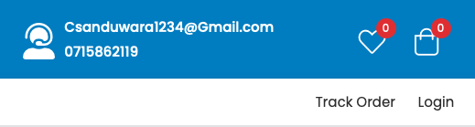

Figure 1

**Sweet Alert Package:** SweetAlert is used to show popup dialog boxes in the website  
  


Figure 2

**Toastr:** toastr package is used to show validations and success messages and error messages  
  


Figure 3

Entity-Relationship Diagram of the website  
  
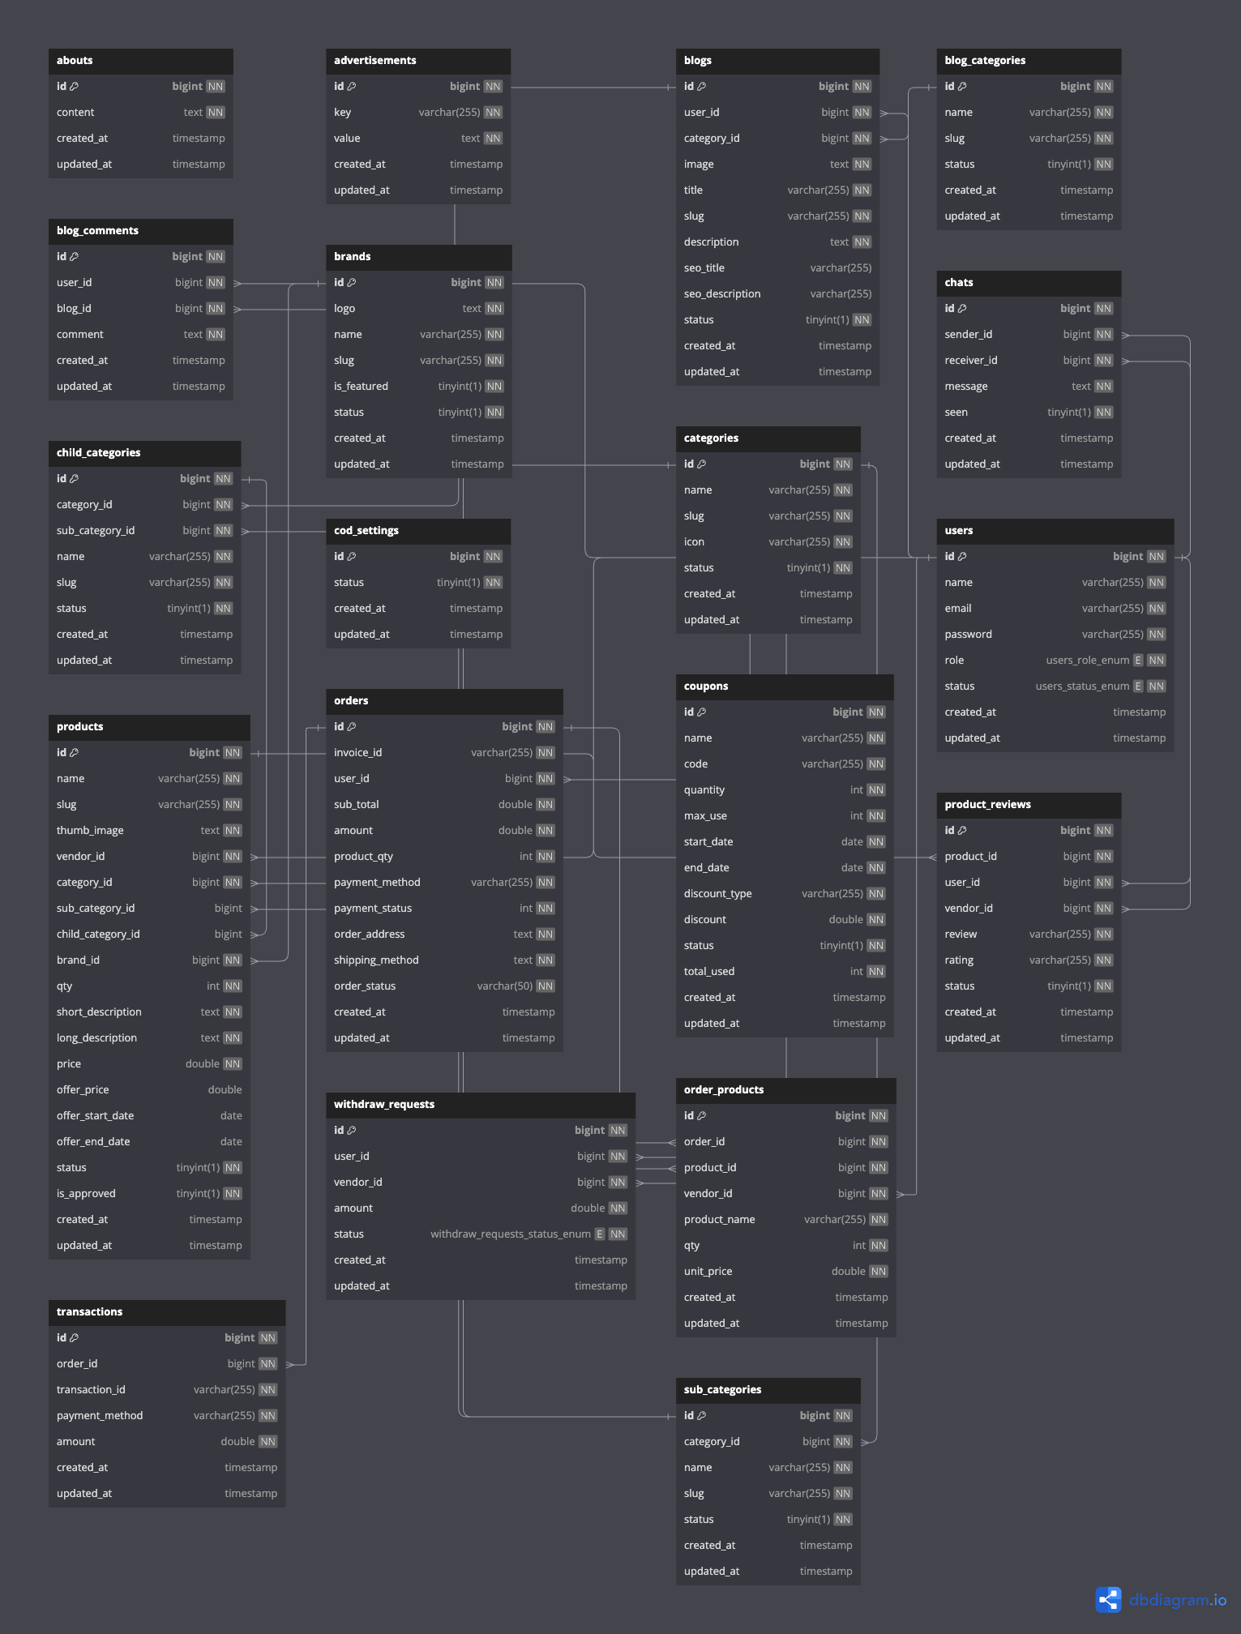

ER DIAGRAM

note: this diagram was made based on the MySQL database of the website to get a more accurate diagram  
Mind Map for the website  
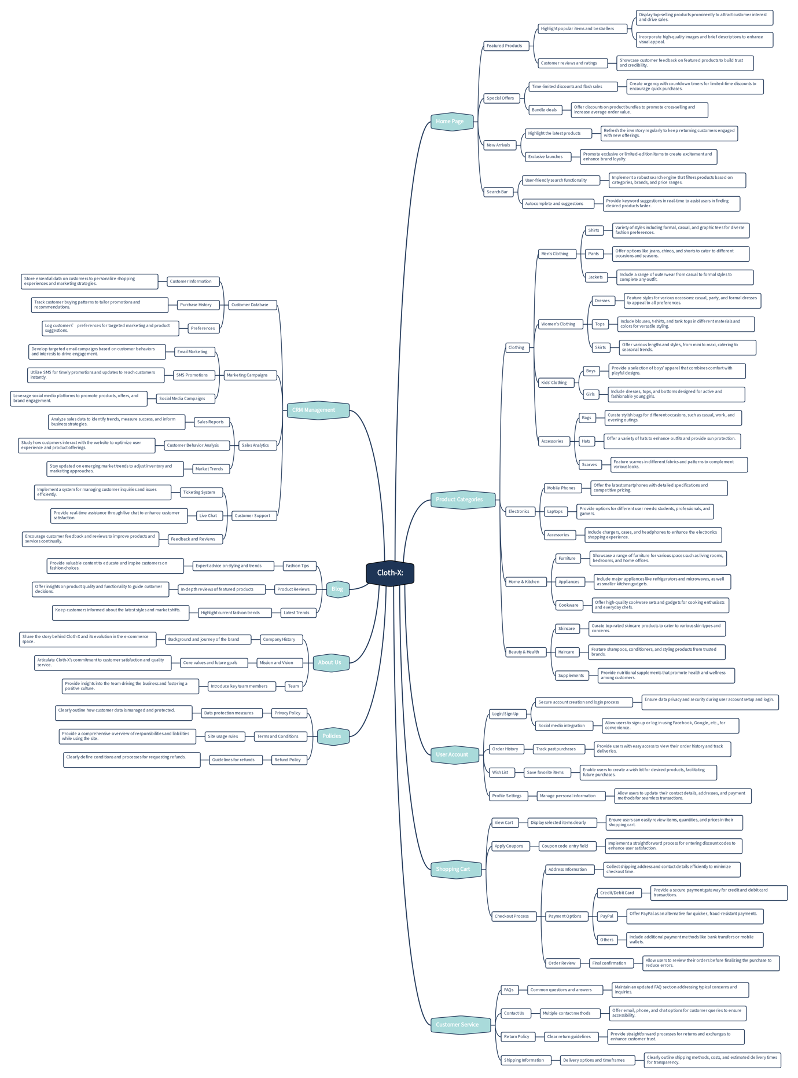

Mindmap

System Features

**User Features:**

* **Cart Features** – add to cart, select quantity, view cart, proceed to checkout, apply coupon codes, keep shopping, view total cart price, view product details through the cart, choosing the shipping method and clear cart features are included in the cart features.
* **Checkout Screen** – Select address that the user has already added in their account dashboard, add a new address through the checkout screen, selecting the delivery method and placing the order are available on the checkout screen feature.
* **Payment Getaways** – user can choose to pay for the product through PayPal, stripe, razor pay or cash on delivery and it will show the order summary on the payment getaways screen.
* **Order Tracking** – Order tracking with the order invoice ID, shopping by(Shows who bought the product), Status of the order, tracking of the order, user can track the order with 4 steps || --- Pending --- Order Processing --- On The Way --- Delivered.
* **Coupon System** – User can use coupon codes set out by the admin to get a discount when purchasing an item.
* **User Authentication** – User authentication is done with custom **toastr** validations and email verification have been done using mail-trap.
* **Flash Sale** – User can use the flash sale section to buy items on a discounted price set by the admin from the admin dashboard.
* **Buy Products from Different Vendors**: User can buy different products from different vendors throughout the site
* **User Dashboard Features**: User is able to access their own dashboard, this dashboard has order tracking, viewing reviews and viewing wish-listed items at one place, user can also add multiple addresses for their own convenience to buy products easier, user can edit their own user profile and also the user can request to be a vendor from the dashboard after filling out an application (if it is approved by the admin user can become a vendor and sell products on their own vendor shop). User can also head back to the homepage using the “go to homepage” button from the dashboard
* **Chat System**: There is a chat system implemented in the dashboard, allowing the users to chat with either vendors or the admin thus providing a better customer care service.
* **Subscription Service**: User can subscribe to the newsletter and the admin can send email to all the subscribed users (this is done through mailtrap)

**Vendor Features:**

* **Vendor Dashboard Features:**Vendor can track sales, orders, earnings, reviews and listed products from their own dashboard.  
    
  Vendor is able to list products for their own vendor shop in the “vendors section” of the website (but this must be approved by the admin beforehand otherwise it will not show up).  
    
  Vendor is able to delist products that they listed from their dashboard as well as view the approval status of the listing.  
    
  Vendor is able to read the reviews that they gotten for their listed products through the “Review” Section from the dashboard.  
    
  Vendor is able to make withdraw request to withdraw the money they earned form their product listings through their dashboard.  
    
  Vendor is able to edit their shop profile from the vendor dashboard.  
    
  Vendor is able to edit their own profile from the vendor dashboard.  
    
  Vendor is able to head to the homepage by clicking on the “Go To Home” button.
* **Chat System:** Vendor can chat with their customers (users) via the chat system using their dashboard to provide a more satisfying customer care experience to their customers (users).

**Admin Features:**

* **Admin Dashboard Features:**  
    
  **Tracking:** todays orders, todays pending orders, total orders, total pending orders, total canceled orders, total complete orders, today’s earnings, this month earnings, this year’s earnings, total reviews, total brands listed, total categories, total blogs, total subscribers, total vendors, total users.  
    
  **Manage categories:** Admin can do crud operations on the categories and it would affect the website’s frontend dynamically.  
    
  **Manage products:** Admin can do crud operations on brands, products, seller products (vendor-listed-products), seller pending products, product reviews.  
    
  **Manage orders:** Admin can do crud operations on every type of orders such as all orders, pending orders, canceled orders, processed orders, dropped off orders, shipped orders, out for delivery orders, delivered orders, canceled orders.  
    
  **Manage transactions:** Admin can do view all the transactions that has been gone through the website in detail.  
    
  **E-Commerce Related Functions:** Admin can put up flash sales, coupons, set shipping rules, edit vendor profile, change payment settings all through the admin dashboard.  
    
  **Manage withdraw:** Admin can create new withdraw methods or delete the existing ones or view the existing withdraw methods, admin can approve or deny the vendor’s withdraw requests.  
    
  **Manage website:** Admin can do crud operations on the website’s frontend appearance with this section (editing slider, home page layout, Vendor Conditions, About page and the terms page.  
    
  **Manage advertisements:** Admin can edit each advertisement and put up new advertising if needed through the website dynamically.  
    
  **Manage blog:** Admin can manage the blog by adding new blog categories, publishing new blogs and admin can also handle and view the blog comments.  
    
  **Manage Footer Settings:** even the footer is made with crud operations to appear on the frontend in this website so the admin can change the footer even dynamically.  
  Manage users: Admin can view all type of users from the admin dashboard and set their status to active or not.  
    
  Manage subscribers: Admin can view all the newsletter subscribers from the admin dashboard and view whether they have a verified account or not and also able to send emails or newsletter to every subscriber of the platform.
* **Chat System:** Admin can text users to provide a better customer care service from the admin dashboard.

## Screenshots of the website

**Home Page**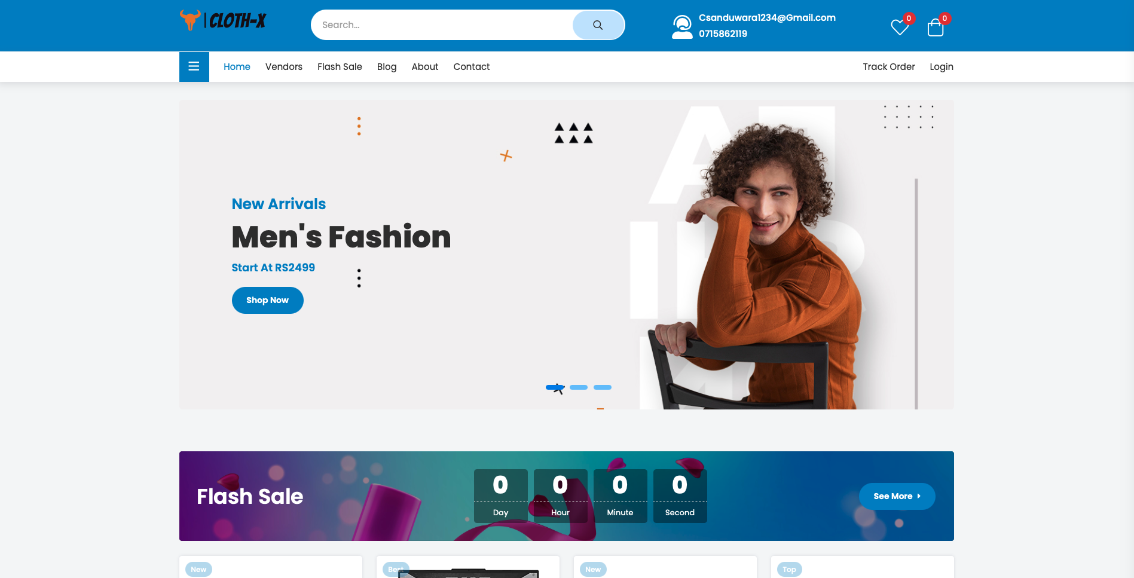

Figure 4

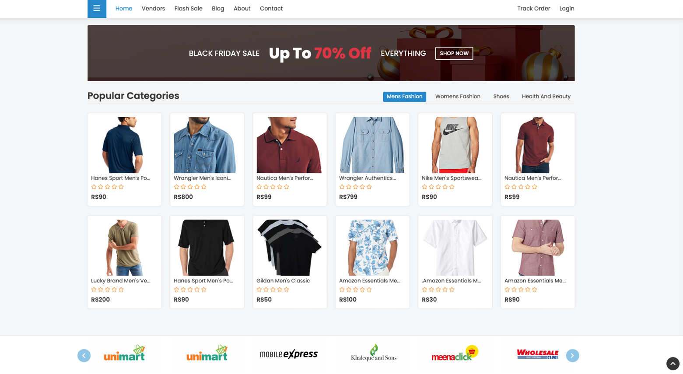

Figure 5

**Footer**  
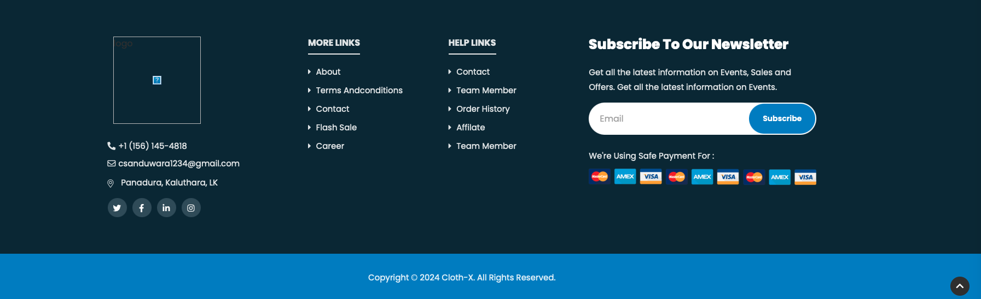

Figure 6

**Login Page**  
  
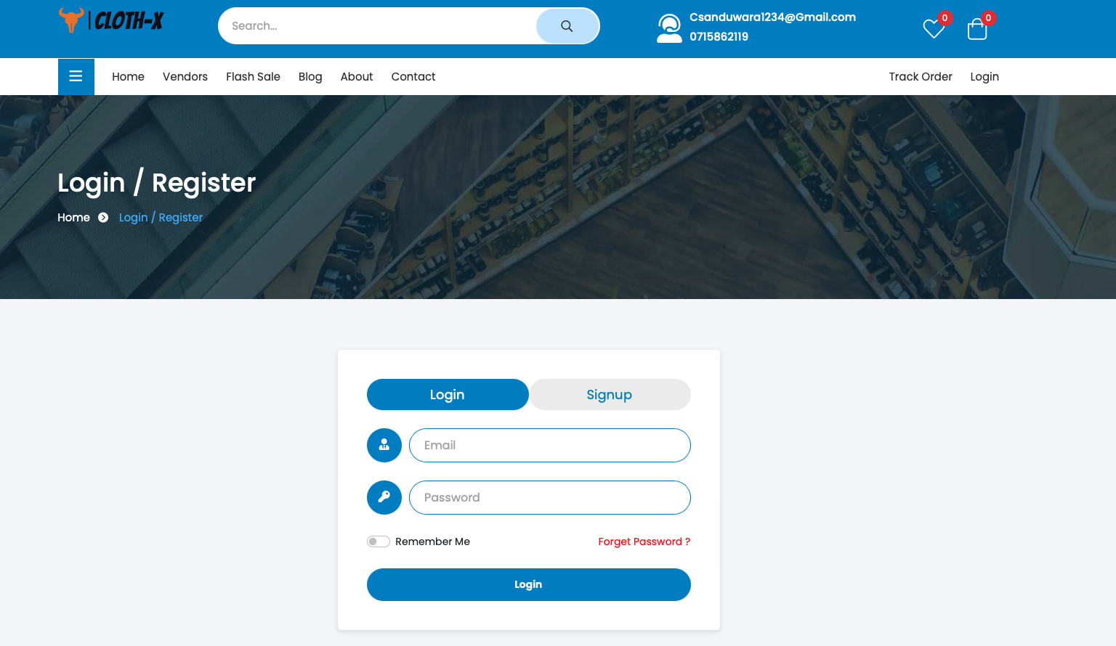

Figure 7

**Signup Page**  
  
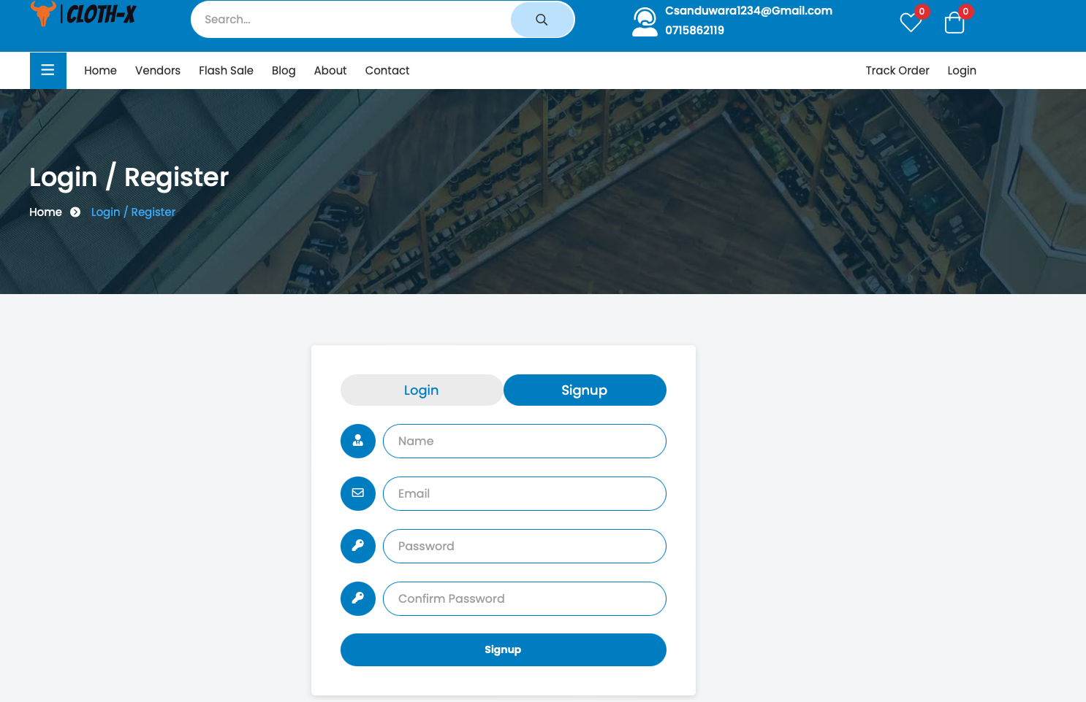

Figure 8

**Order Tracking Page**

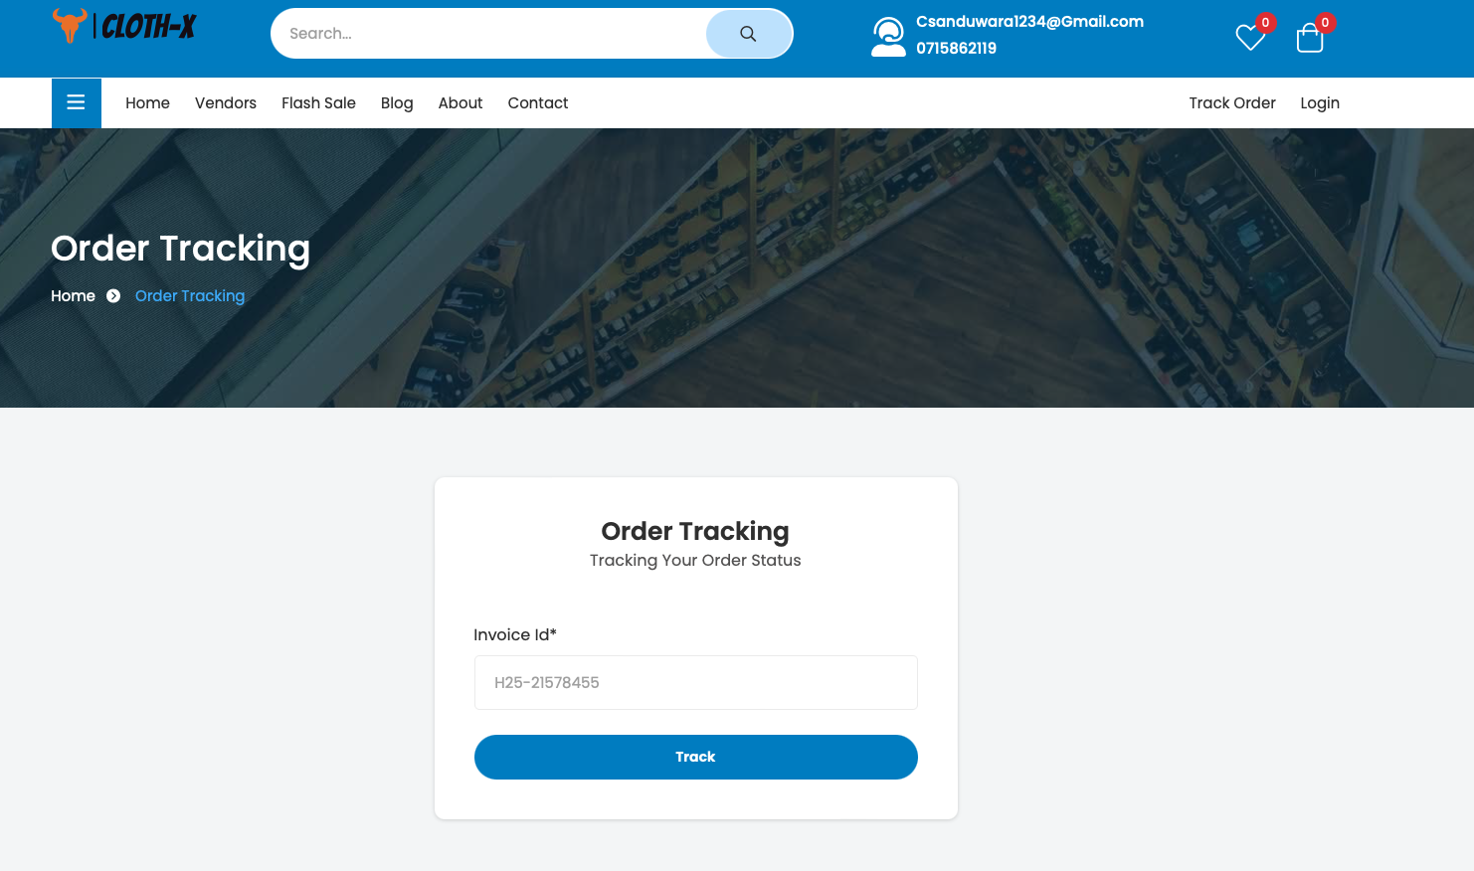

Figure 9

**Order Status Page**

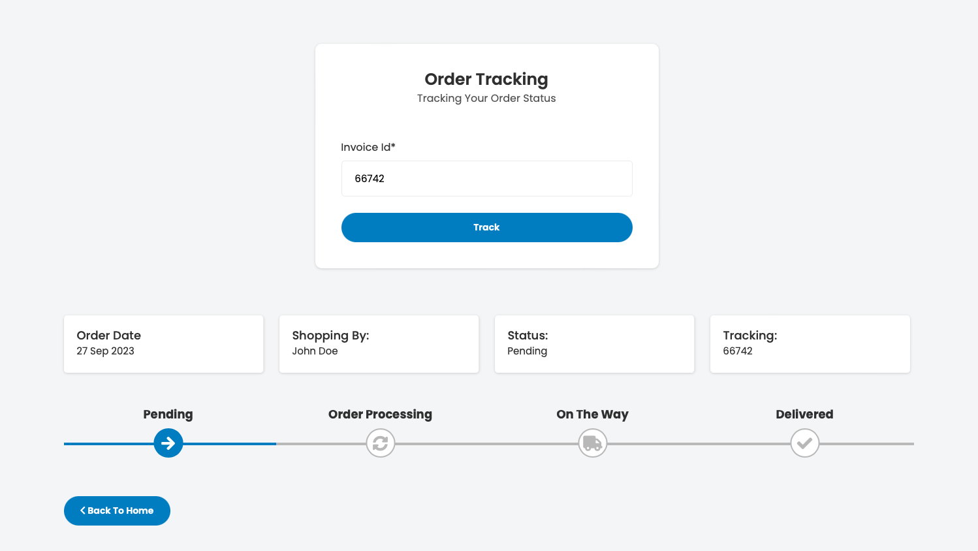

Figure 10

**Vendors Page**  
  
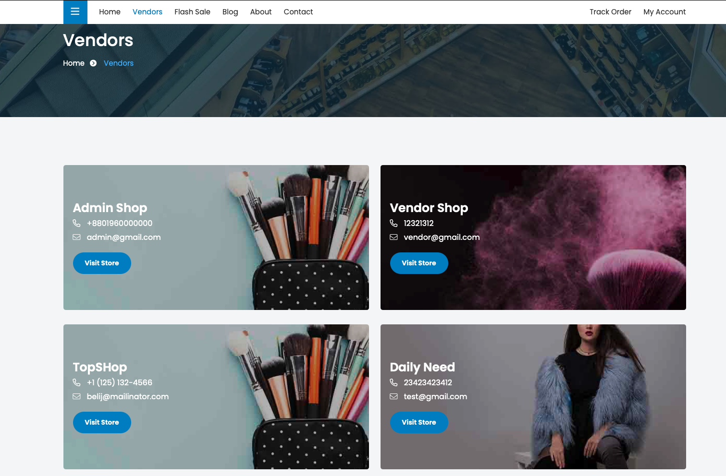

Figure 11

**Flash Sale Page**

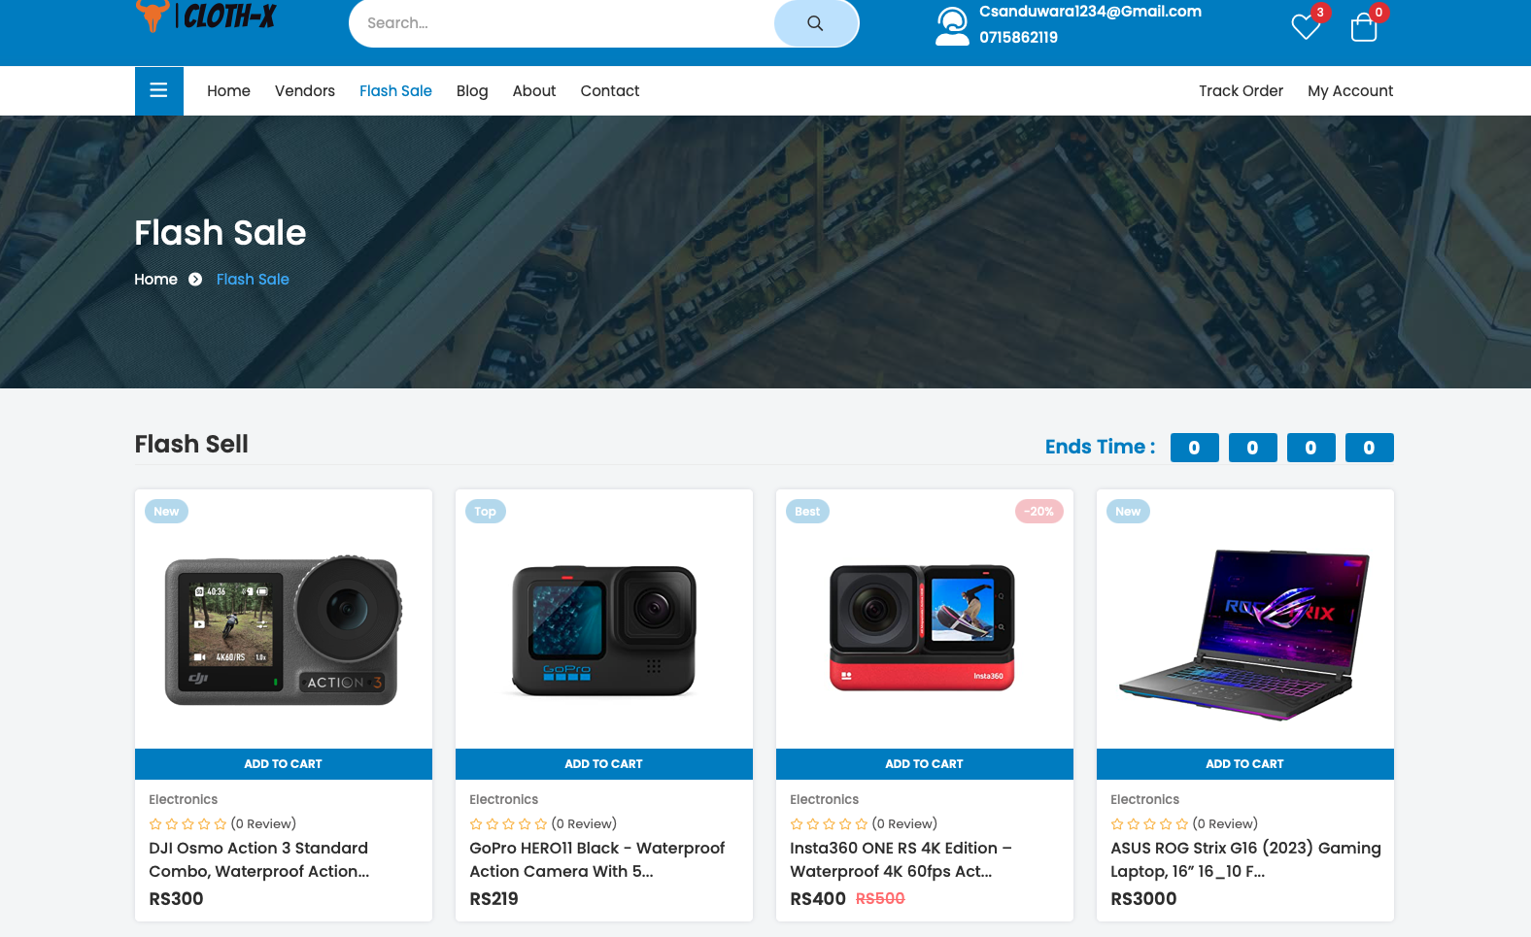

Figure 12

**Product Master Details Page**  
  
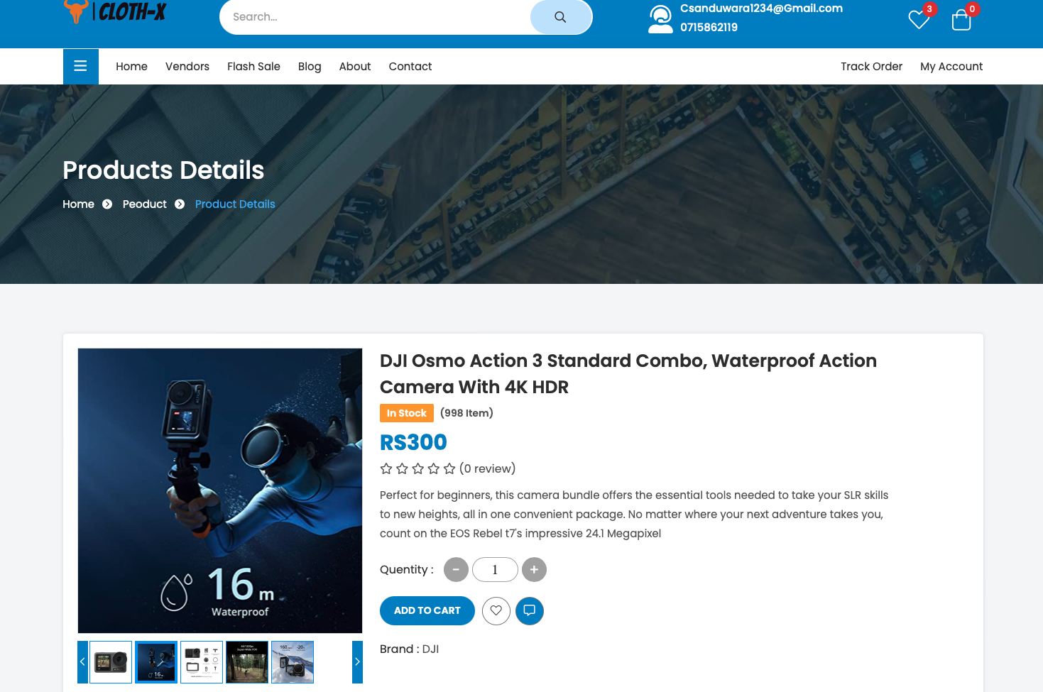

Figure 13

**About Page**  
  
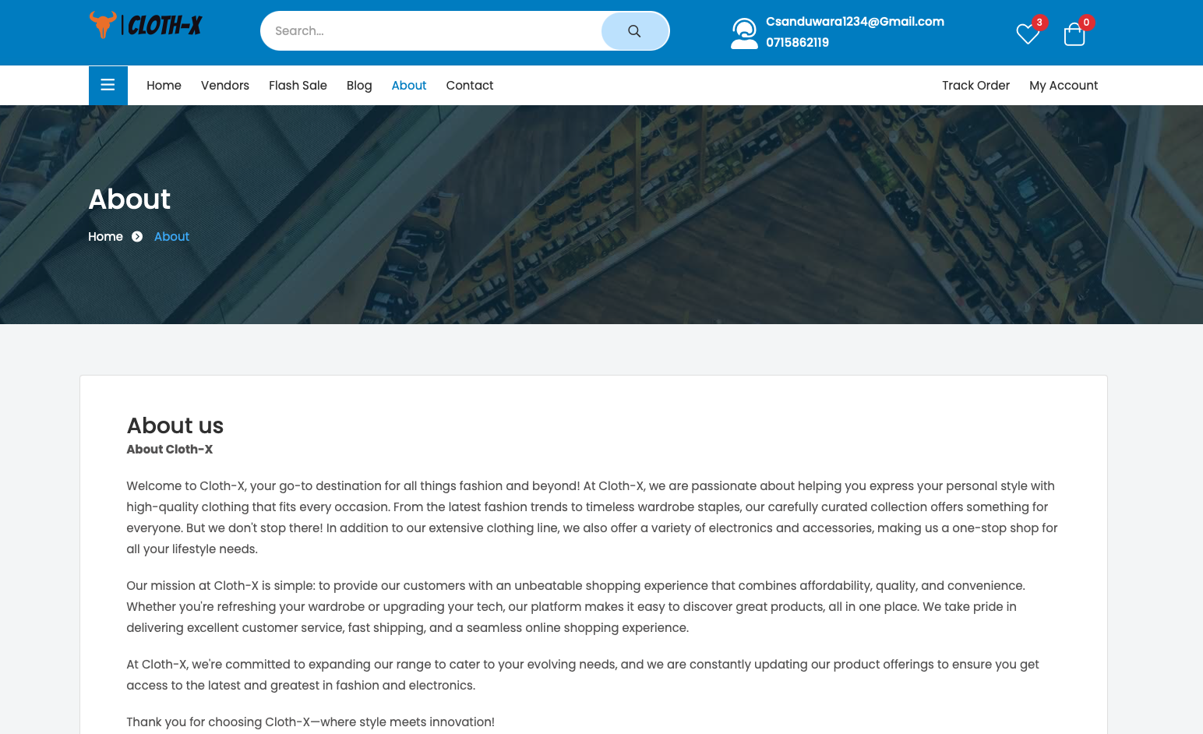

Figure 14

**Contact Page**  
  
  
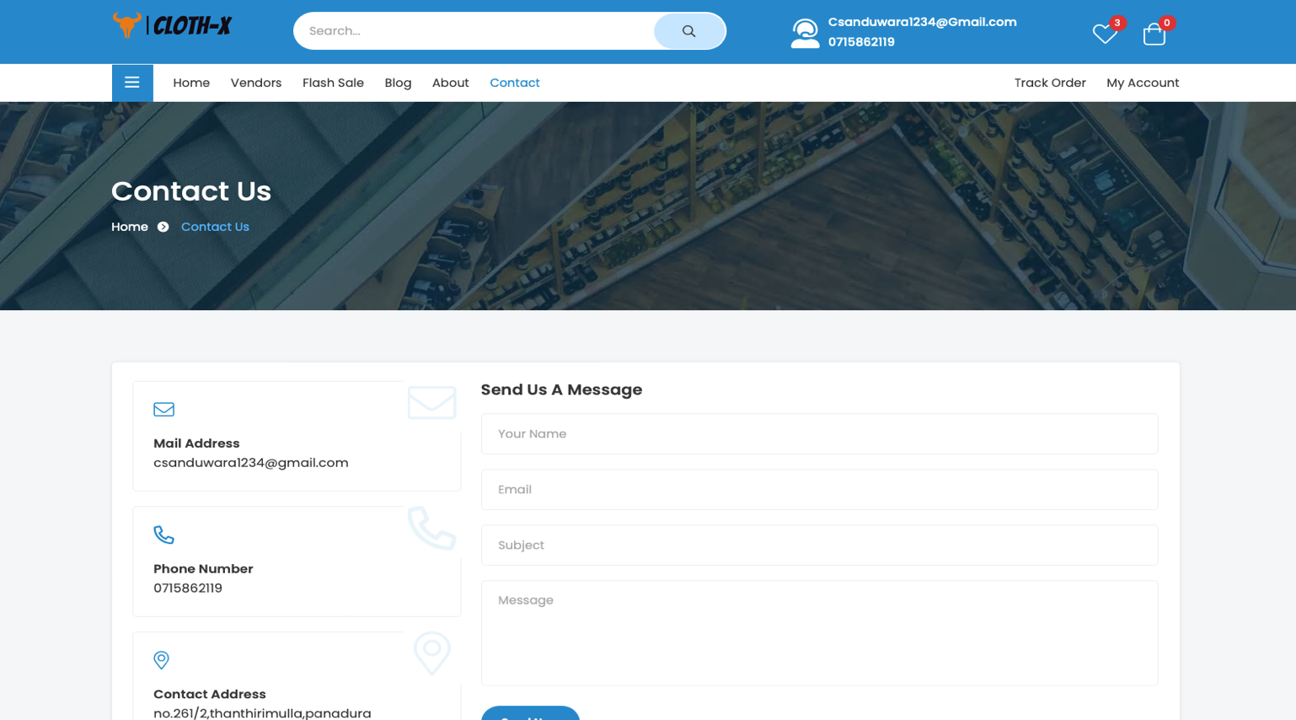

Figure 15

**Blog Page**  
  
  
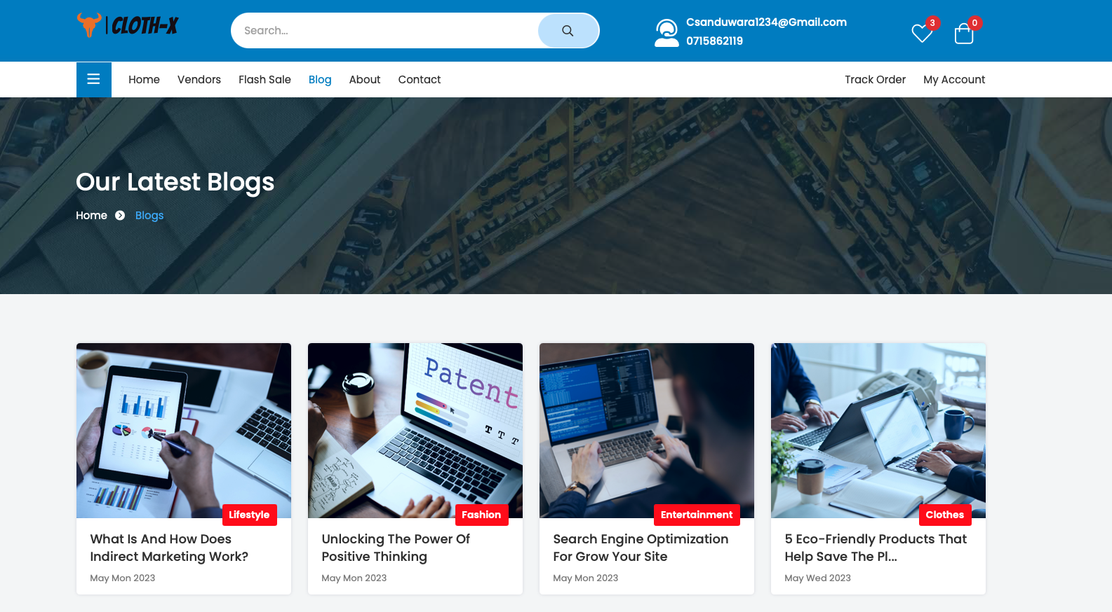

Figure 16

**Vendor Products Page**  
  
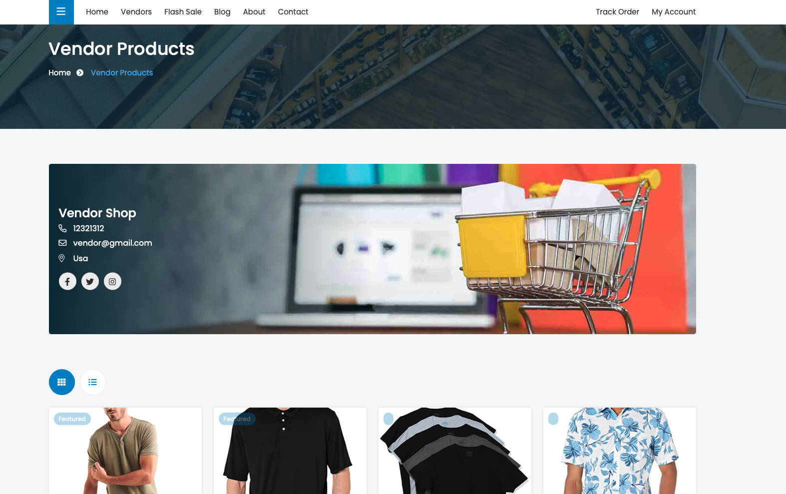

Figure 17

**Wishlist Page**  
  
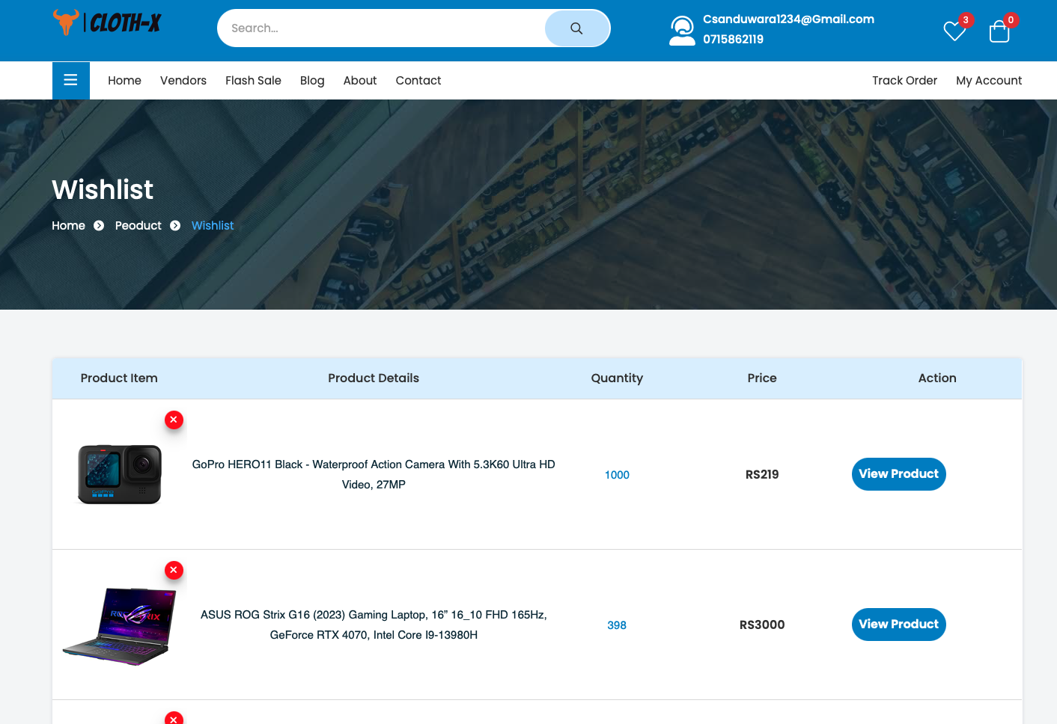

Figure 18

**Side Cart**  
  
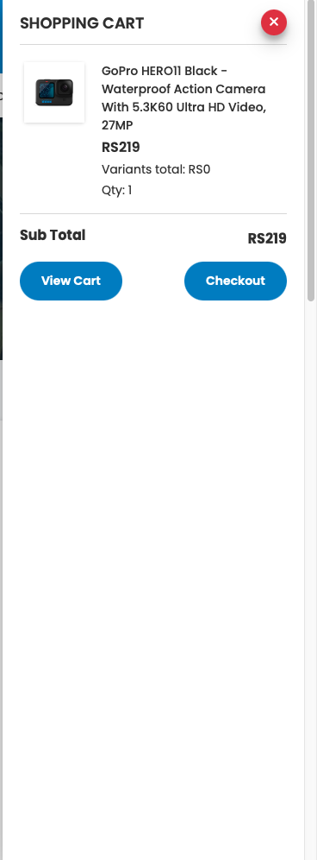

Figure 19

**Cart Page**  
  
  
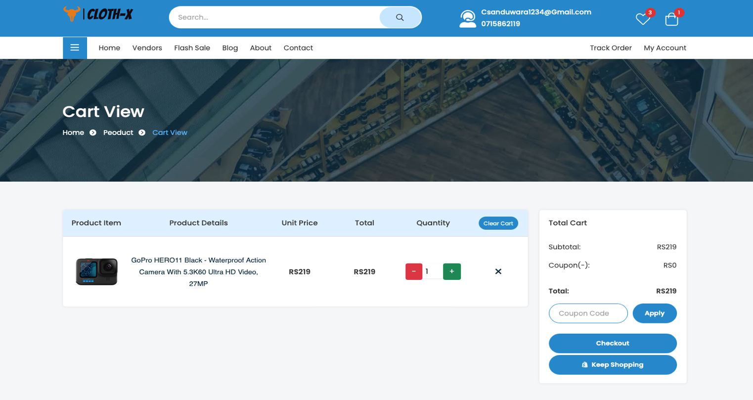

Figure 20

**Checkout Page**  
  
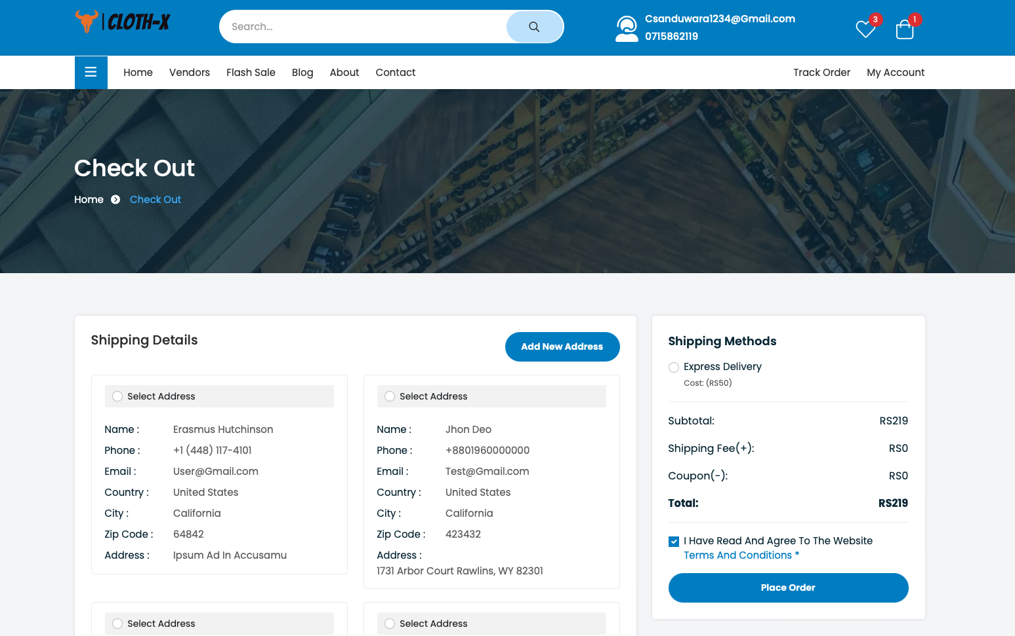

Figure 21

**User Dashboard Page/s**  
  
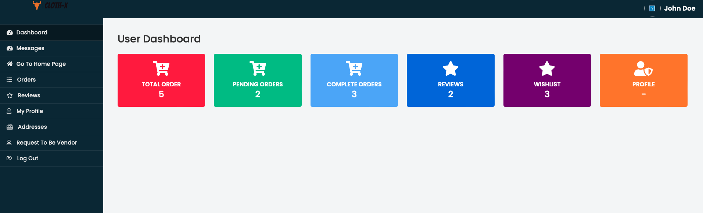

Figure 22

**User Dashboard Chat system**  
  
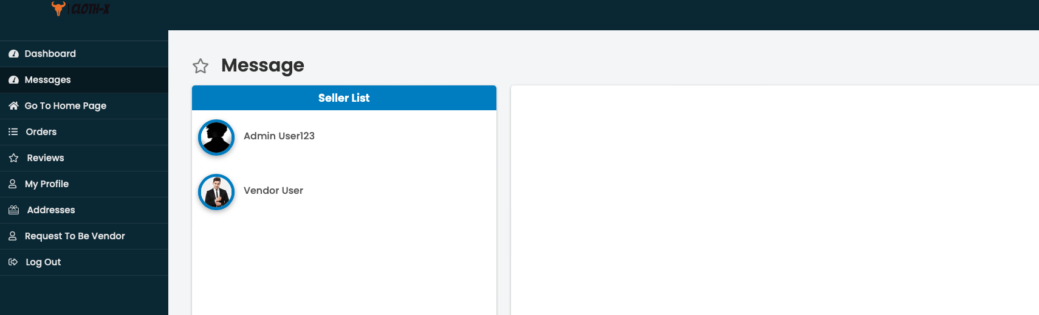

Figure 23

**User Dashboard Orders Screen**  
  
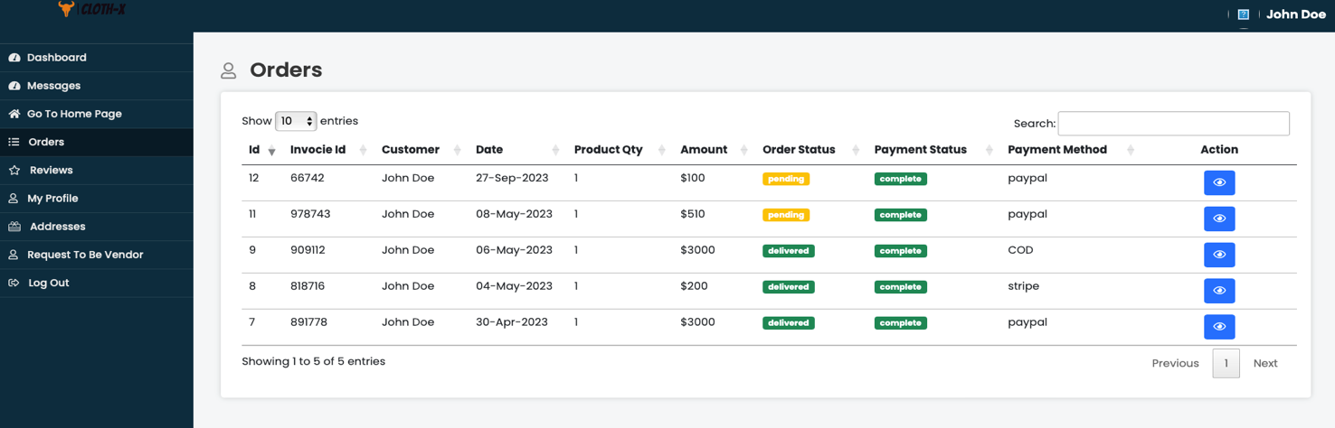

Figure 24

**User Dashboard Reviews Screen**  
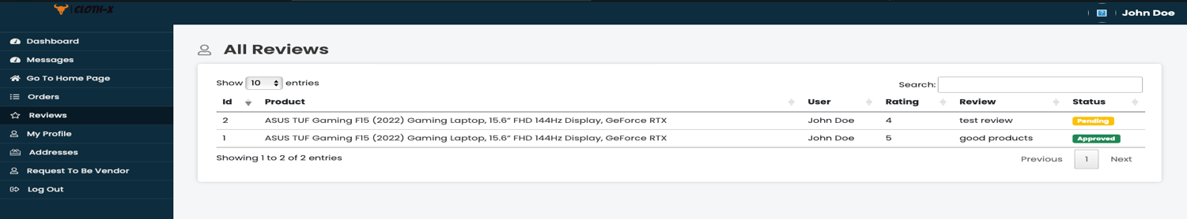

Figure 25

**User Dashboard User Profile Screen**  
  
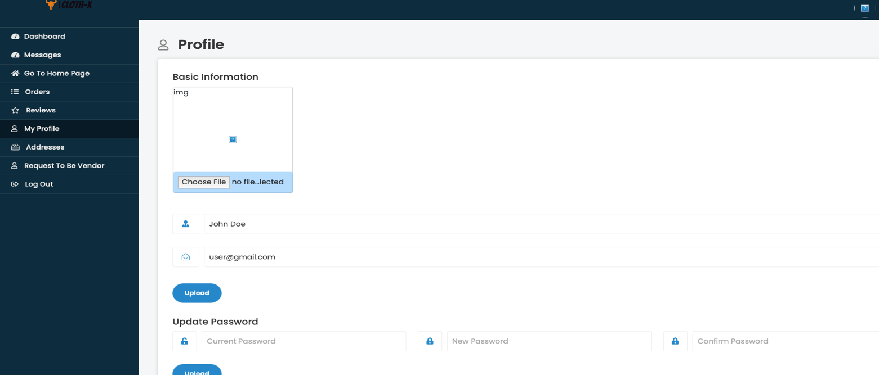

Figure 26

**User Dashboard Addresses Screen**  
  
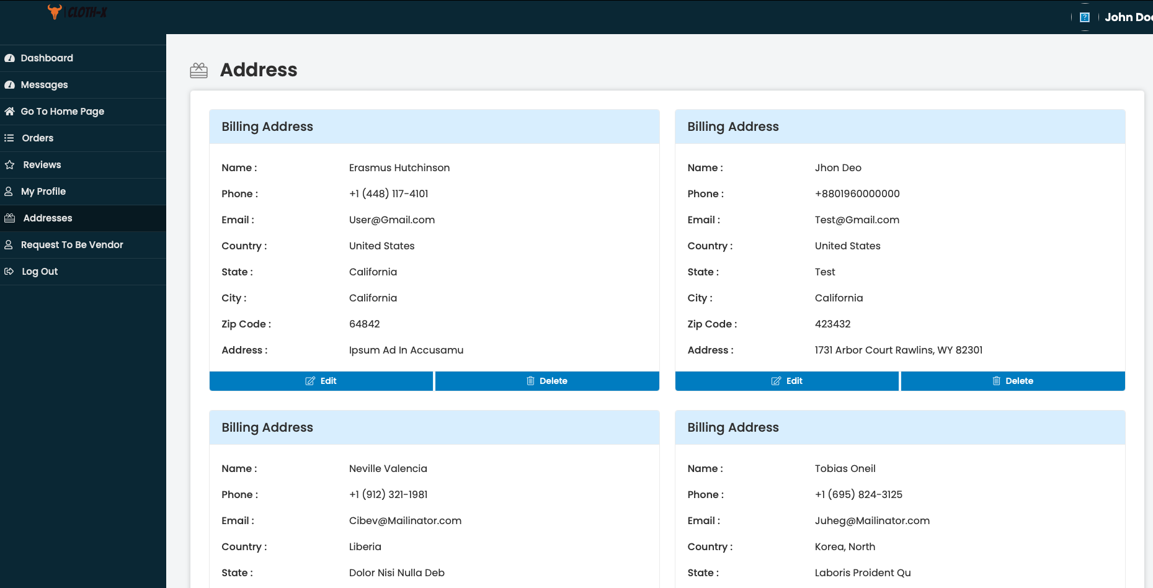

Figure 27

**User Dashboard Request to be a Vendor Screen**  
  
  
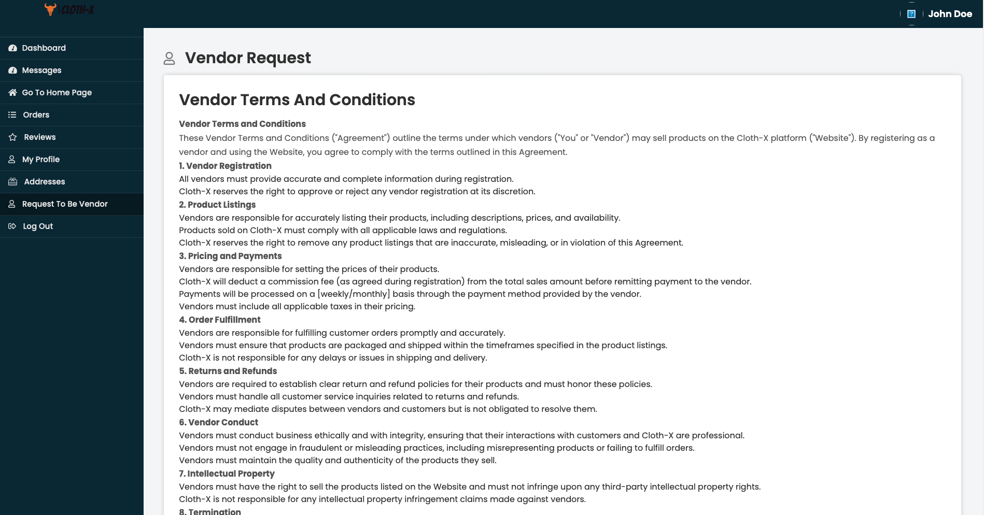

Figure 28

**Vendor Dashboard Page/s**  
  
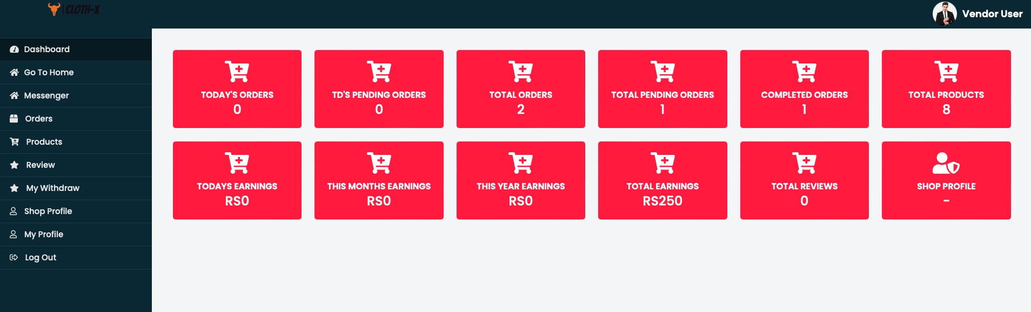

Figure 29

**Vendor Dashboard Chat System**  
  
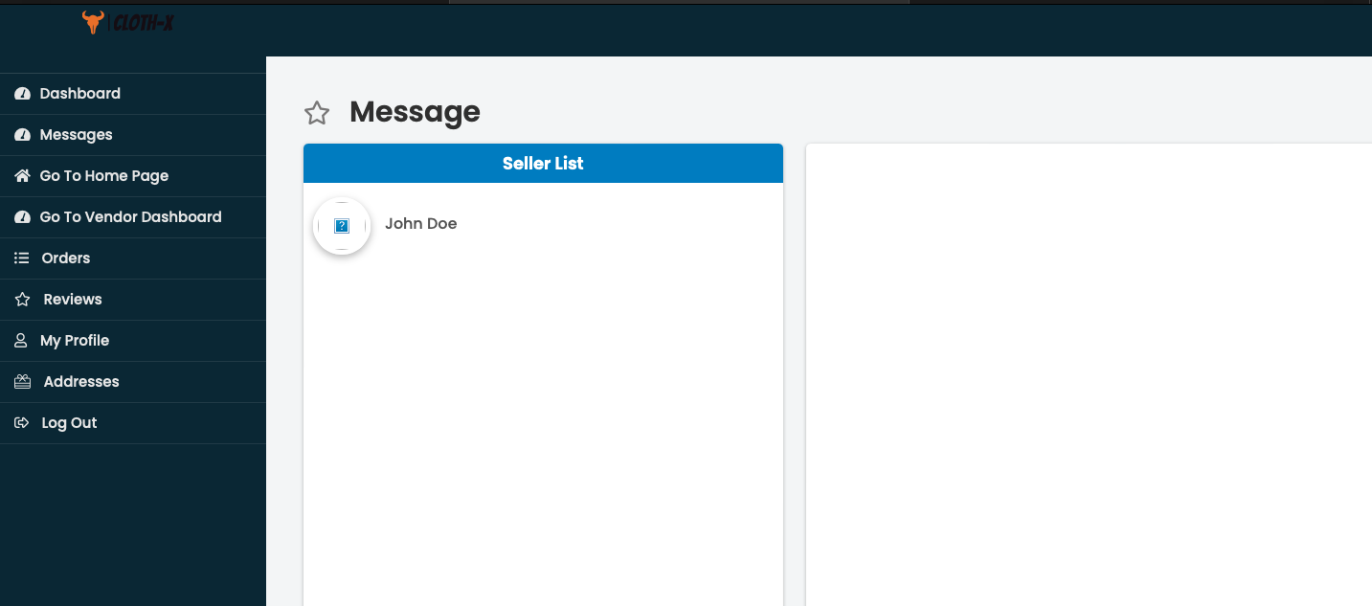

Figure 30

**Vendor Dashboard Orders Page**  
  
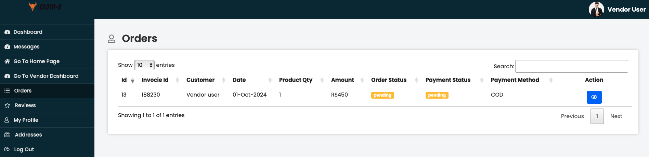

Figure 31

**Vendor Dashboard Reviews Page**  
  
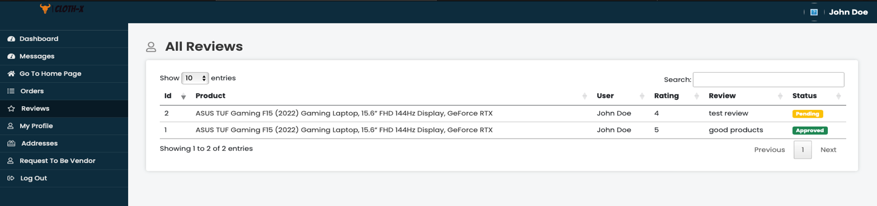

Figure 32

**Vendor Profile Page**  
  
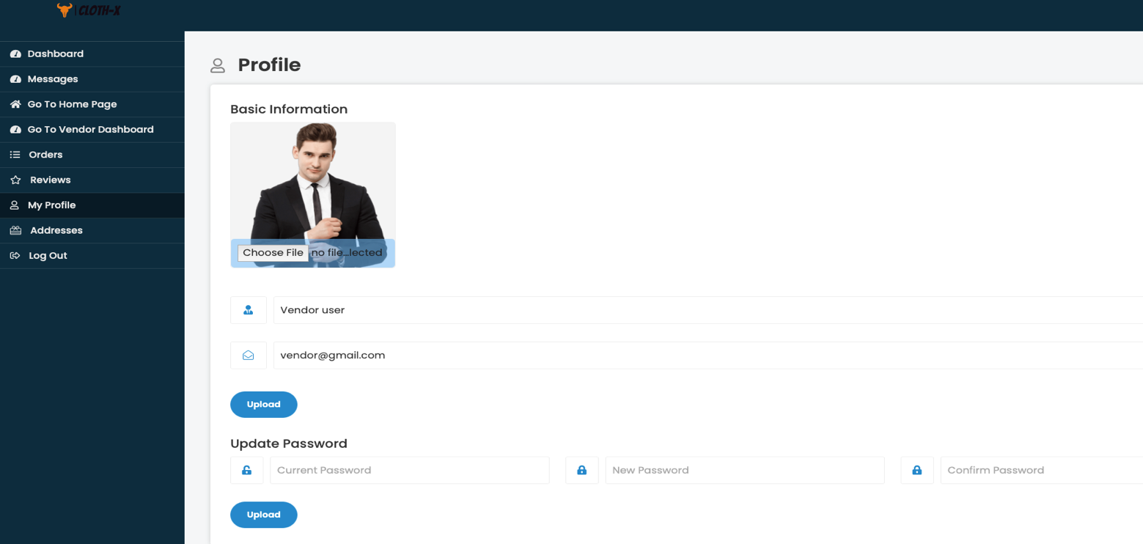

Figure 33

**Vendor Address Page**  
  
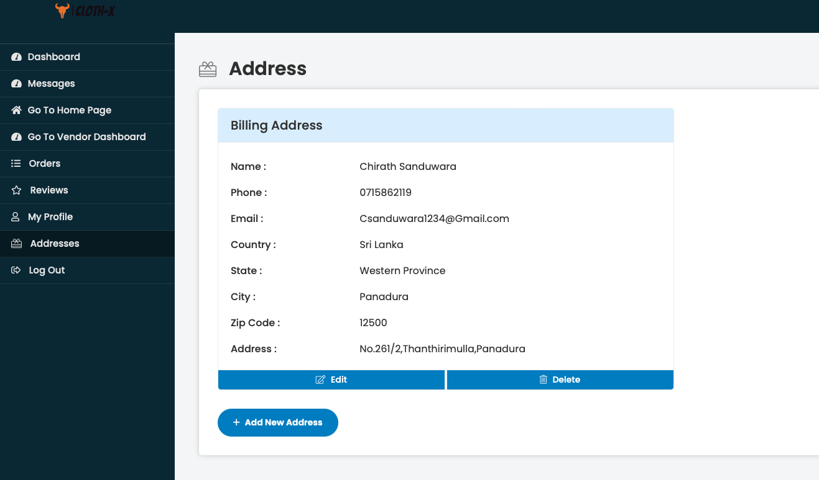

Figure 34

**Admin Dashboard Page/s**  
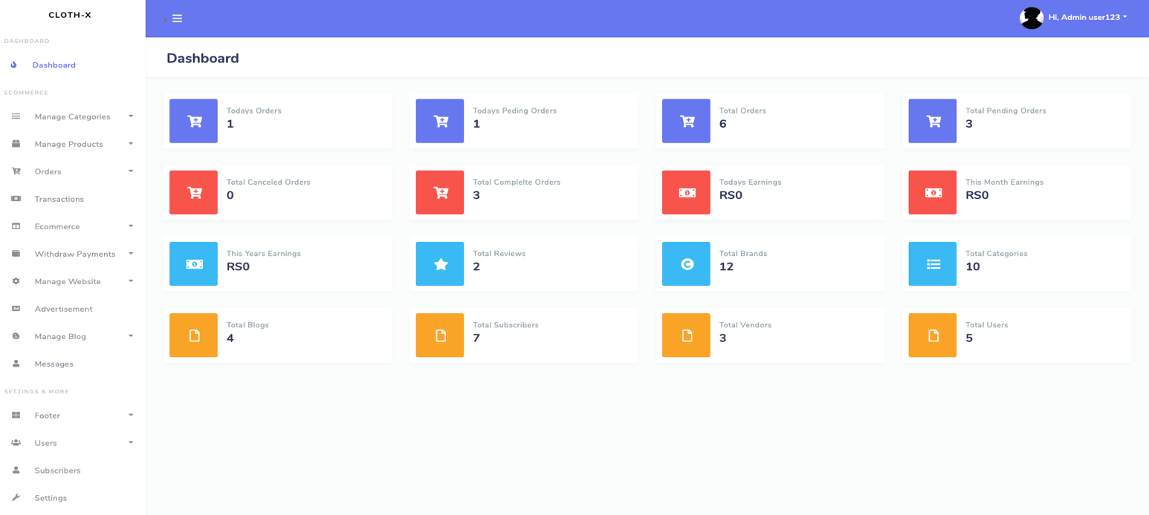

Figure 35

**Manage Category: Category Page**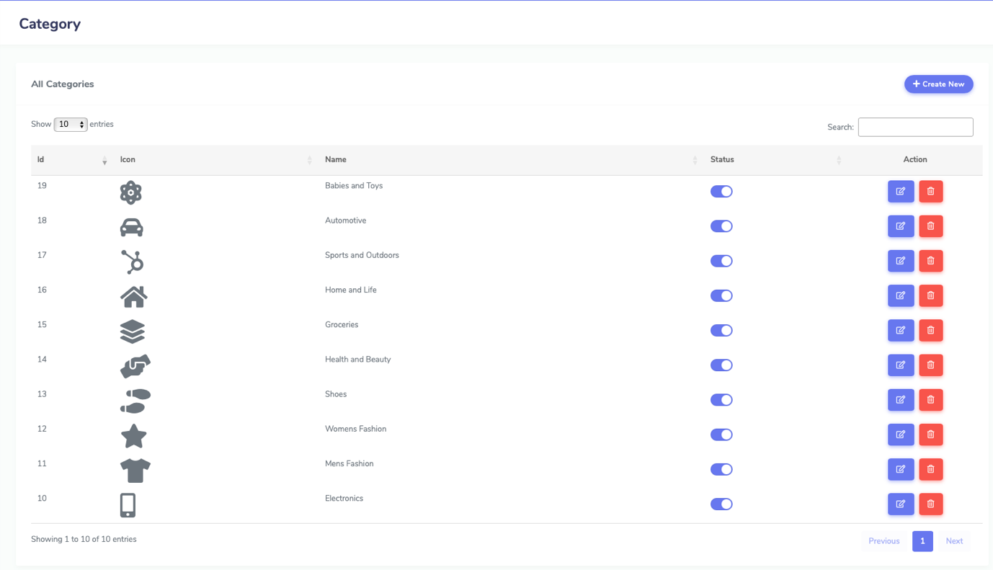

Figure 36

**Manage Category: Subcategory Page**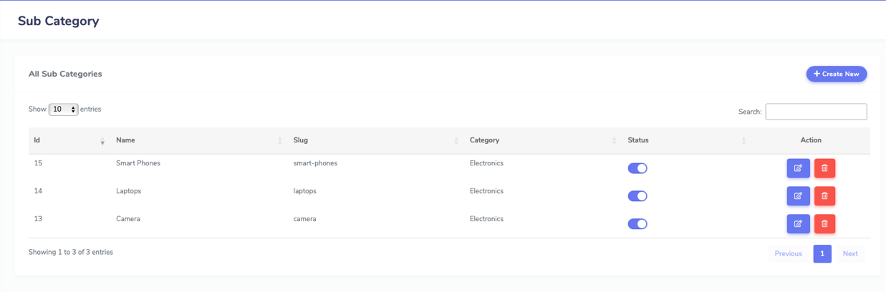

Figure 37

**Manage Category: Child Category Page**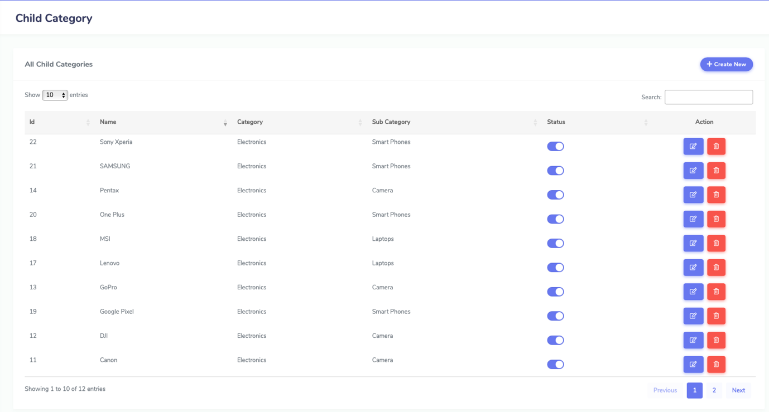

Figure 38

**Orders: Brands Page**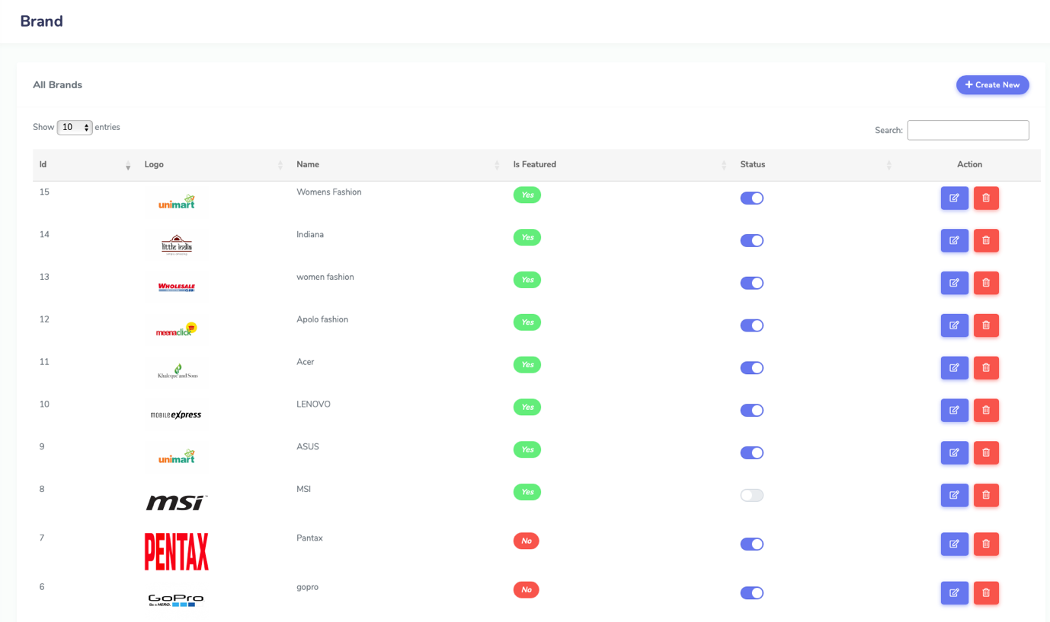

Figure 39

**Orders: Products Page**  
  
 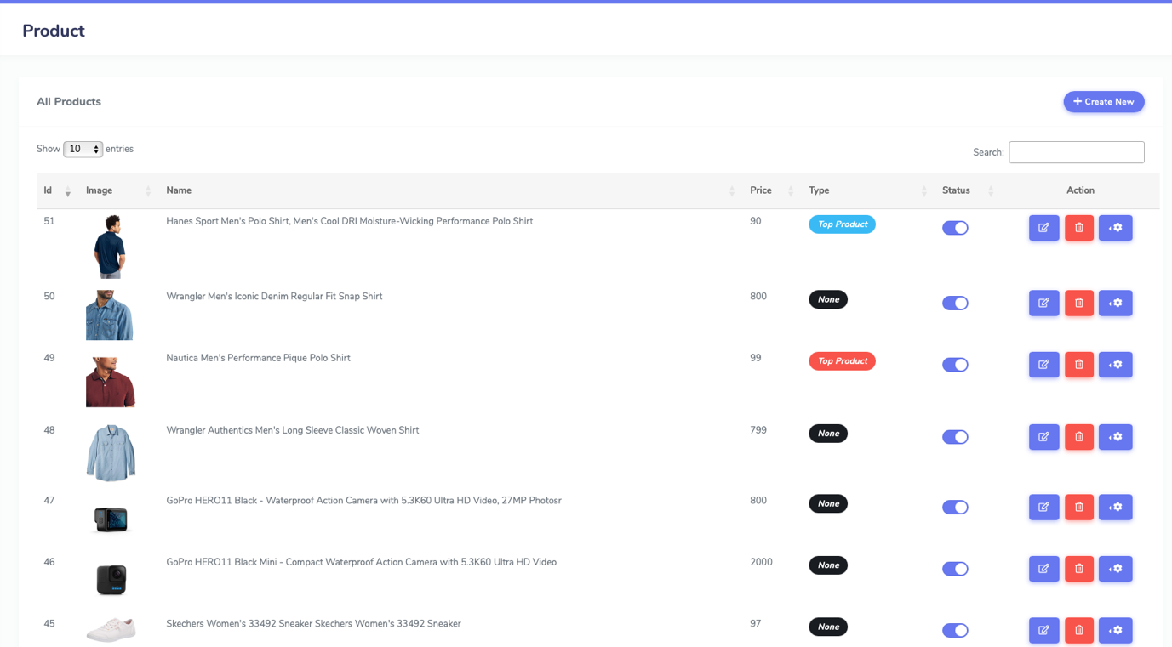

Figure 40

**Order: Seller Products Page**

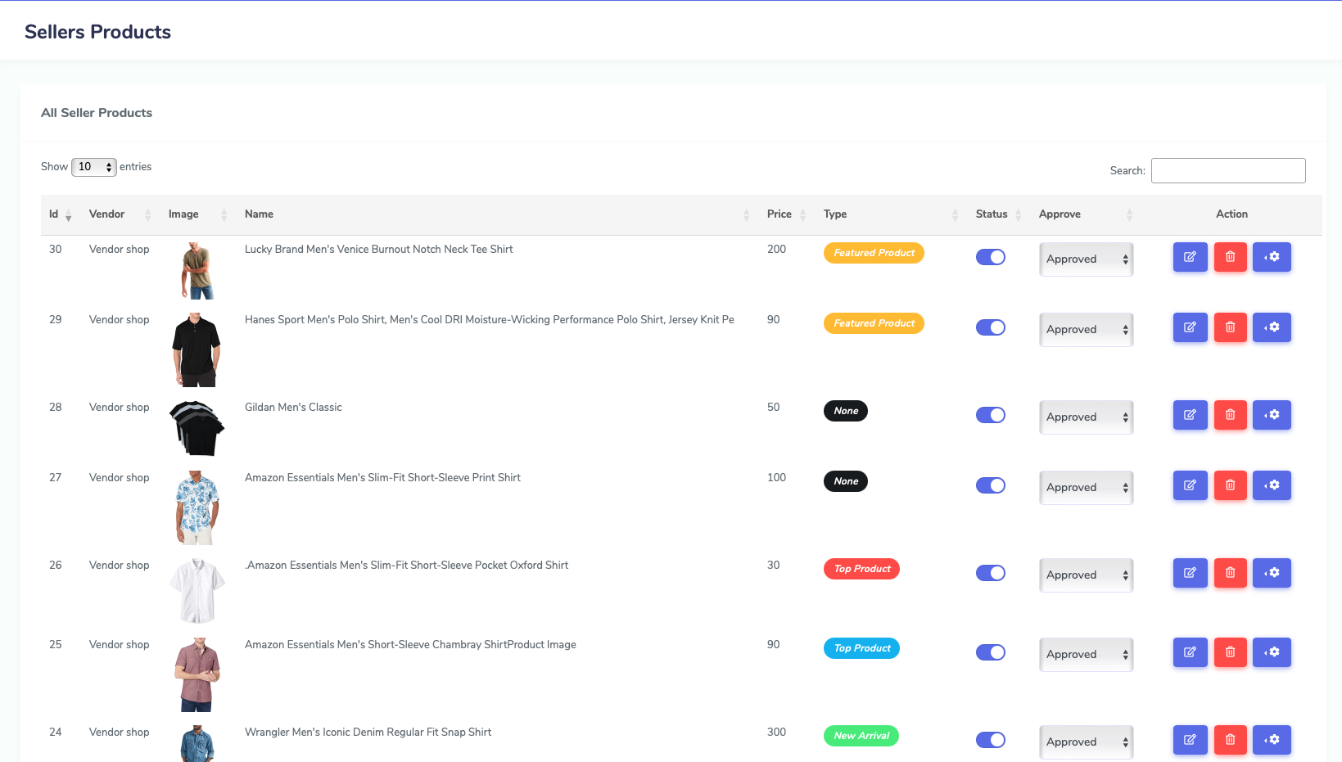

Figure 41

**Order: Seller Pending Products**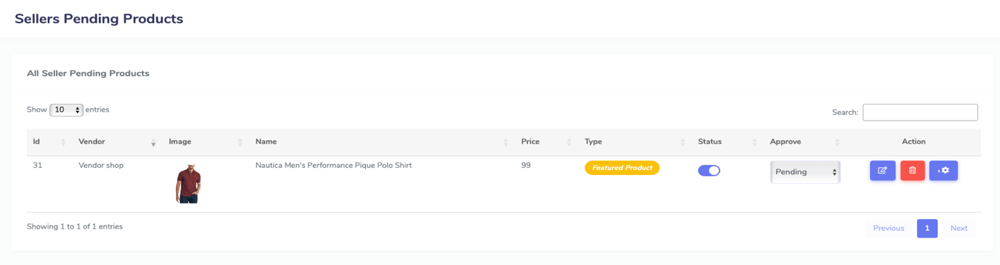

Figure 42

**Order: Product Reviews**  
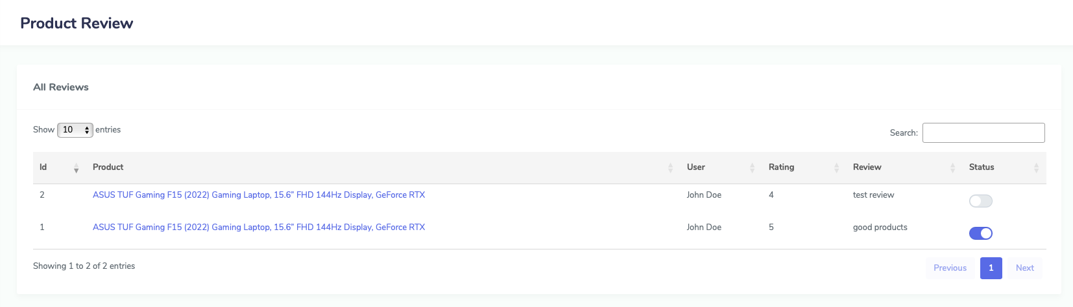

Figure 43

**Transactions Page**

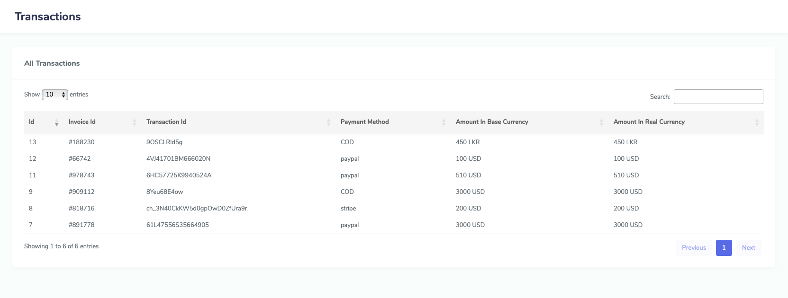

Figure 44

**E-Commerce Page/s**  
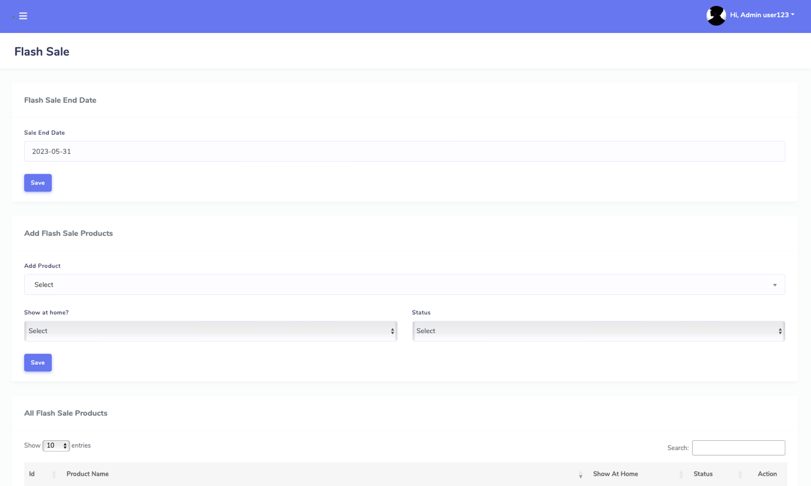

Figure 45

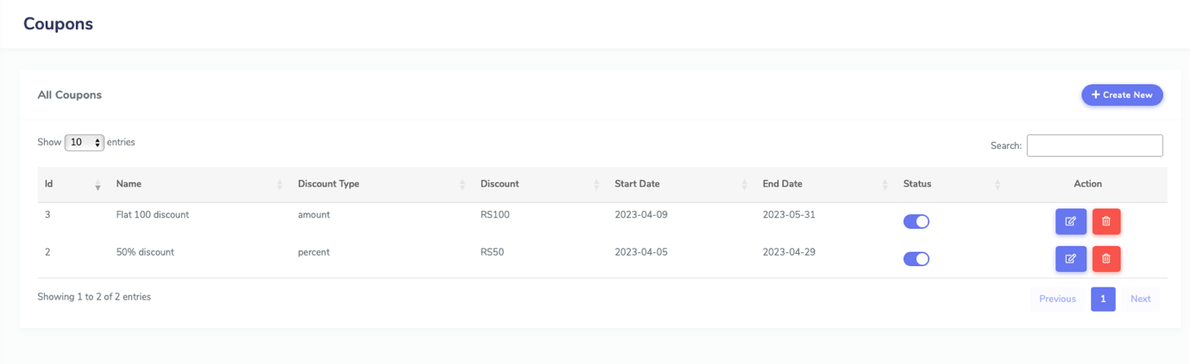

Figure 46

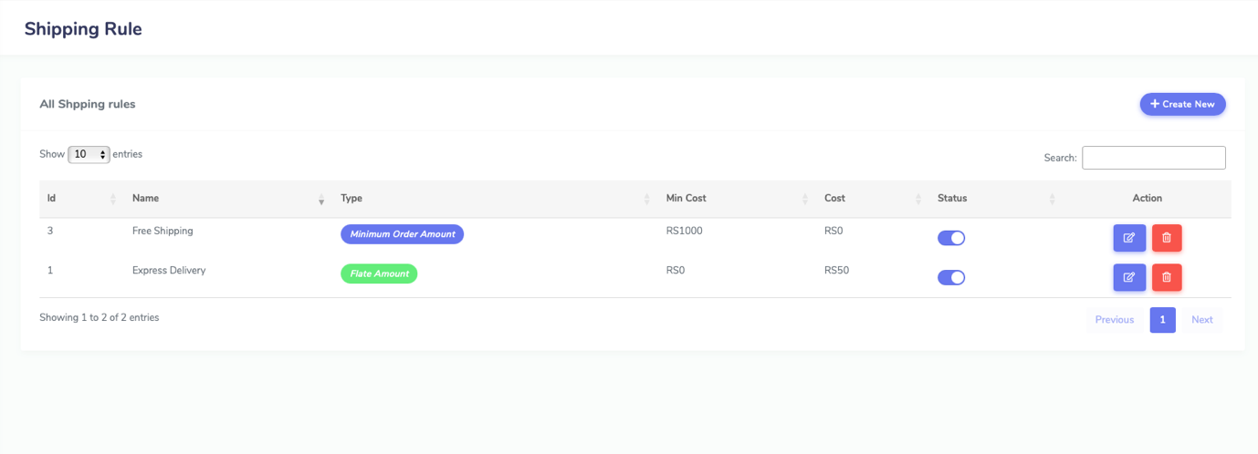

Figure 47

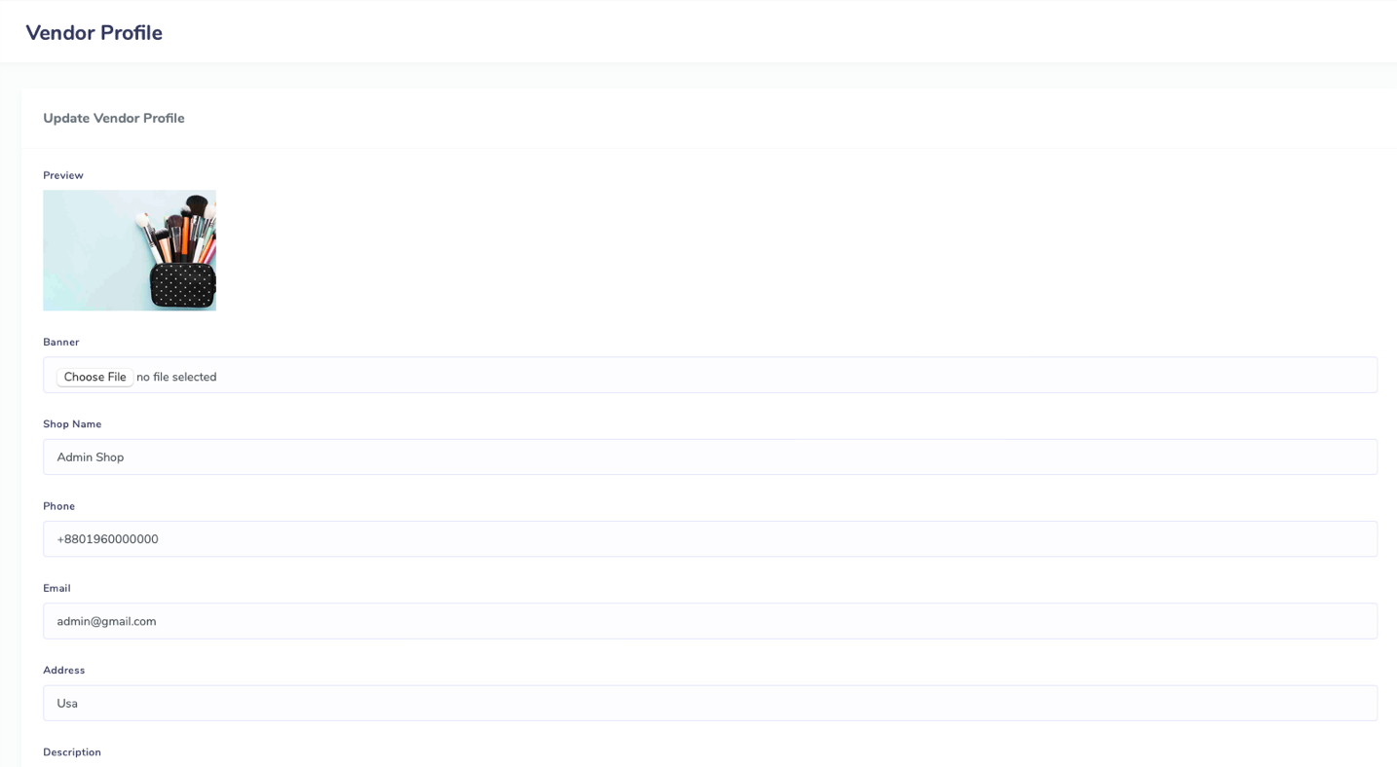

Figure 48

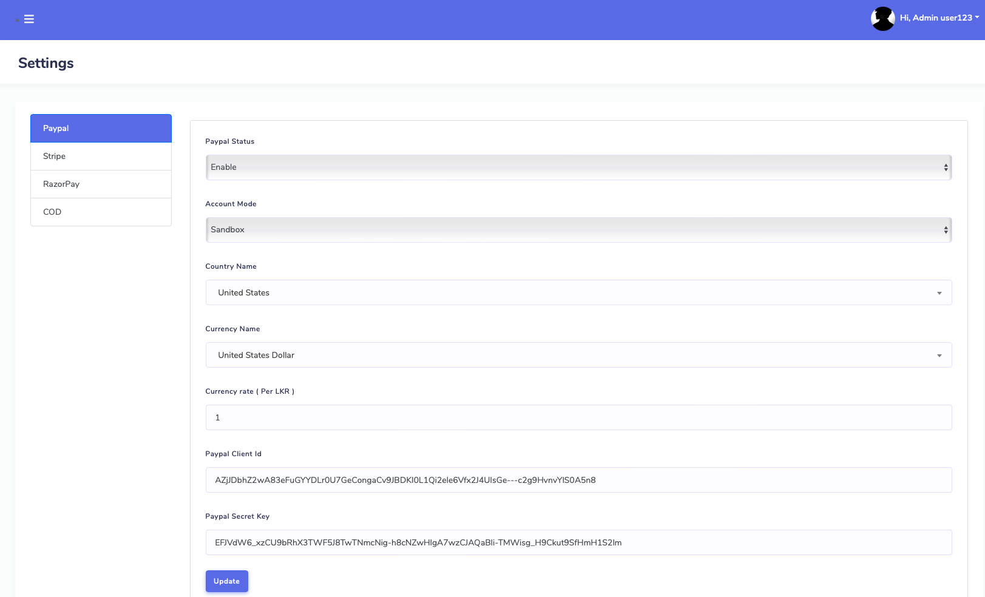

Figure 49

**Withdraw Payment Page/s**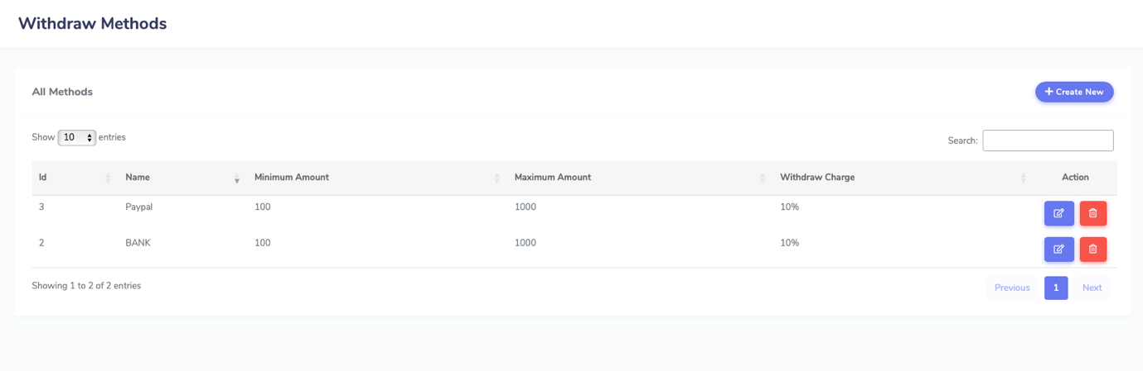

Figure 50

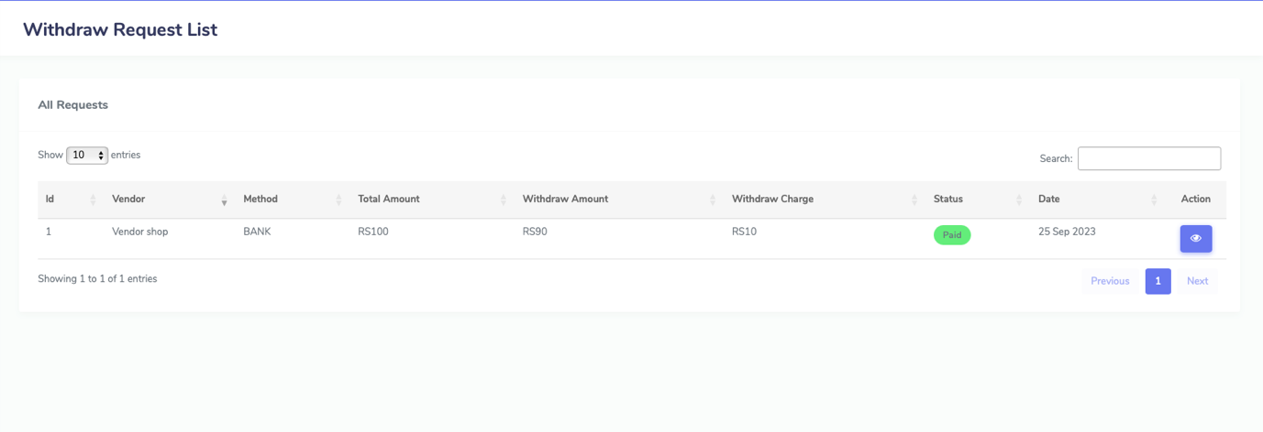

Figure 51

**Manage Website Page/s**

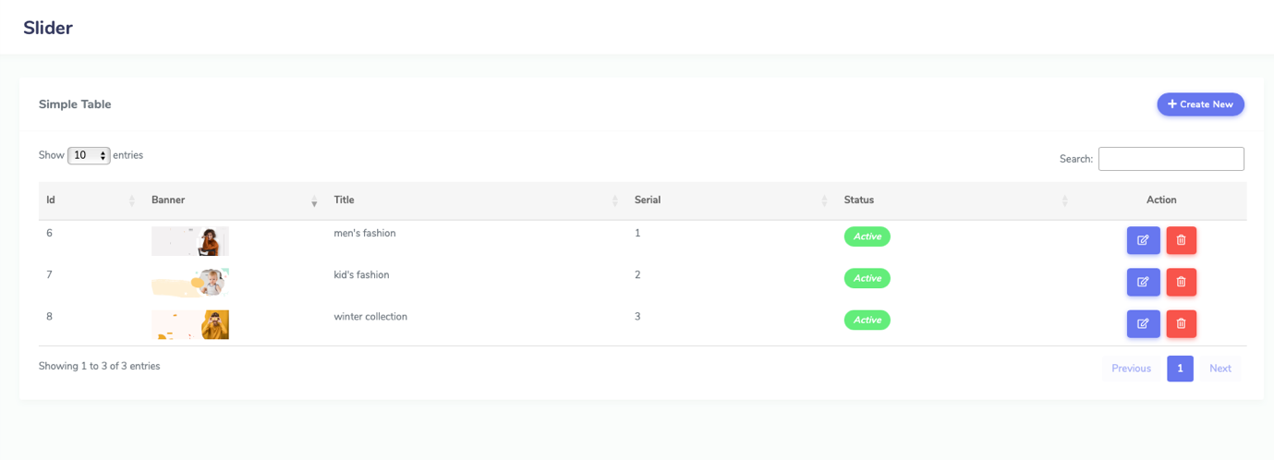

Figure 52

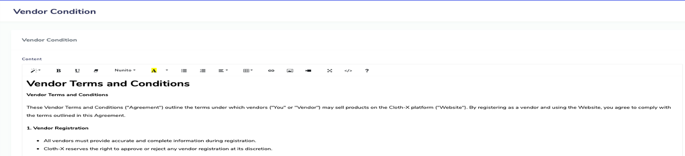

Figure 53

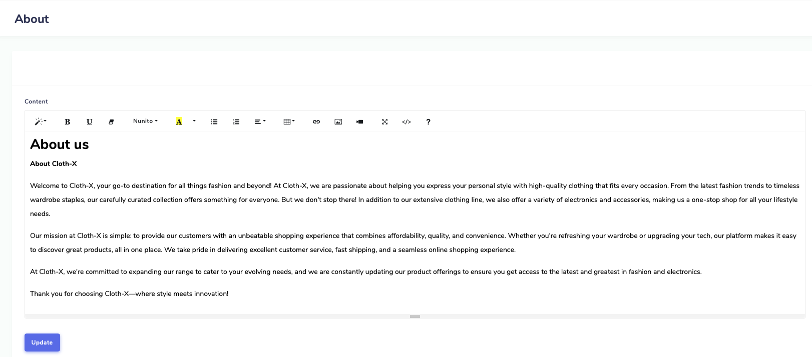

Figure 54

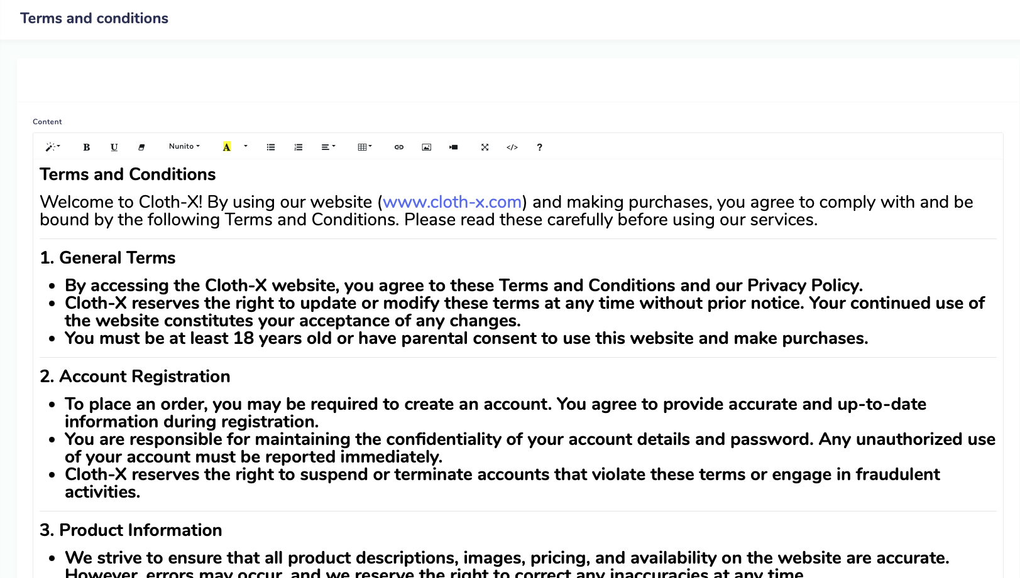

Figure 55

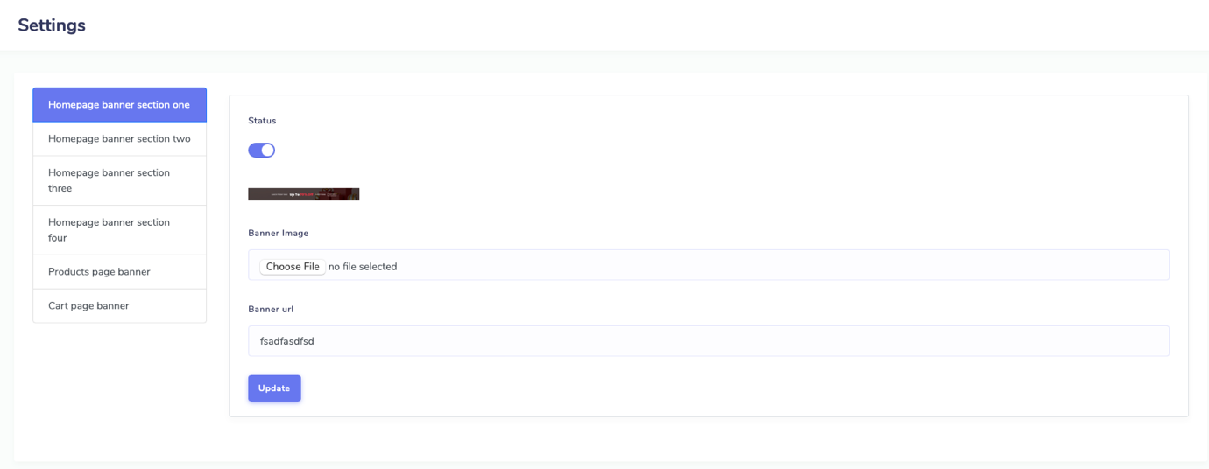

Figure 56

**Manage Blog**  
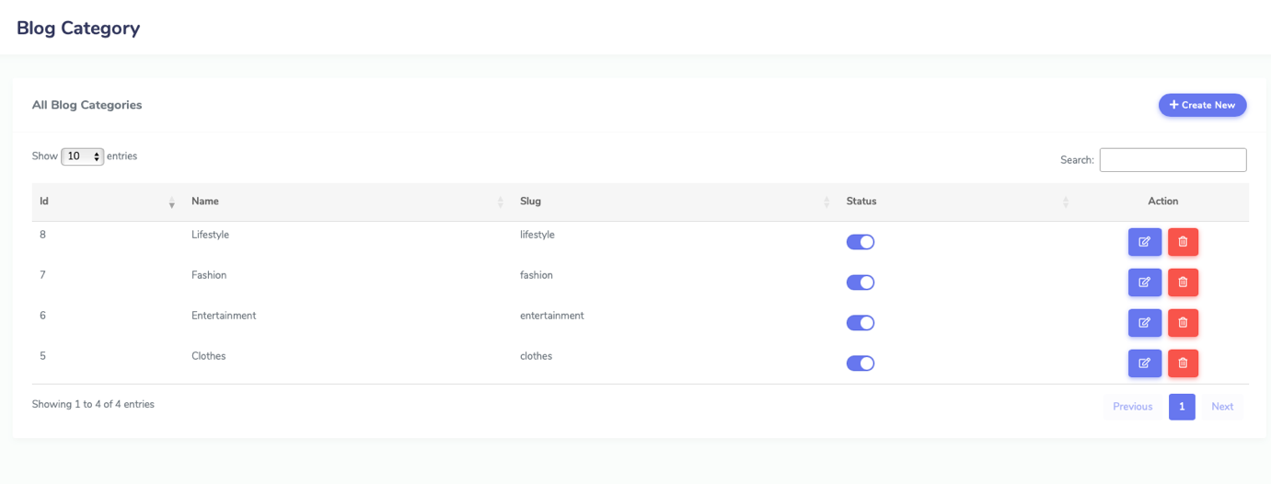

Figure 57

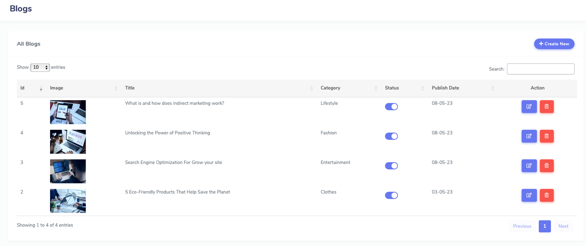

Figure 58

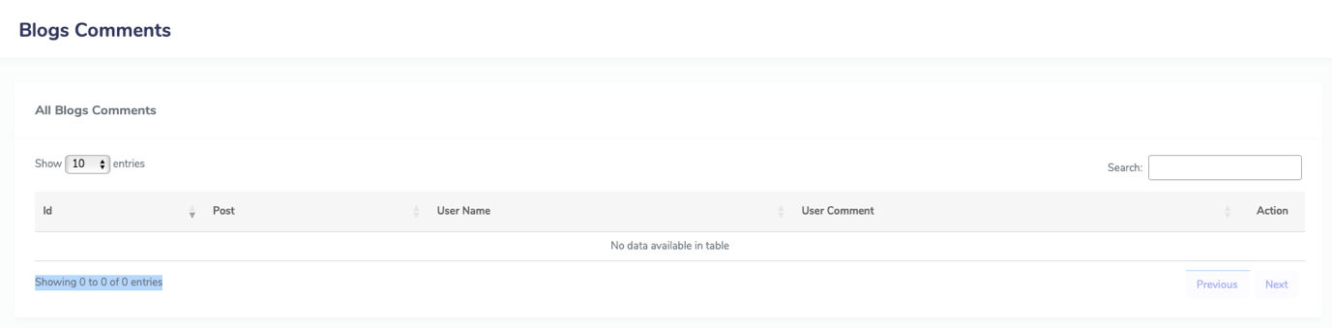

Figure 59

**Admin Dashboard: Chat System**  
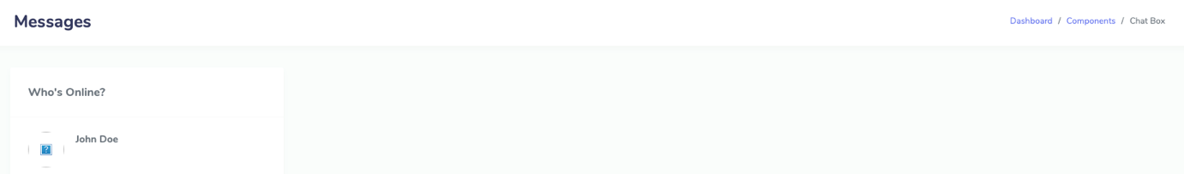

Figure 60

**Admin Dashboard: footer**  
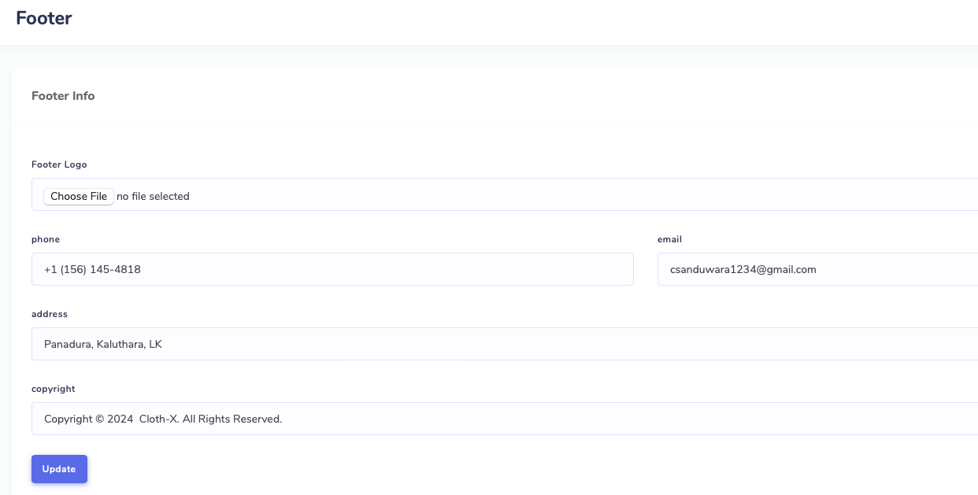

Figure 61

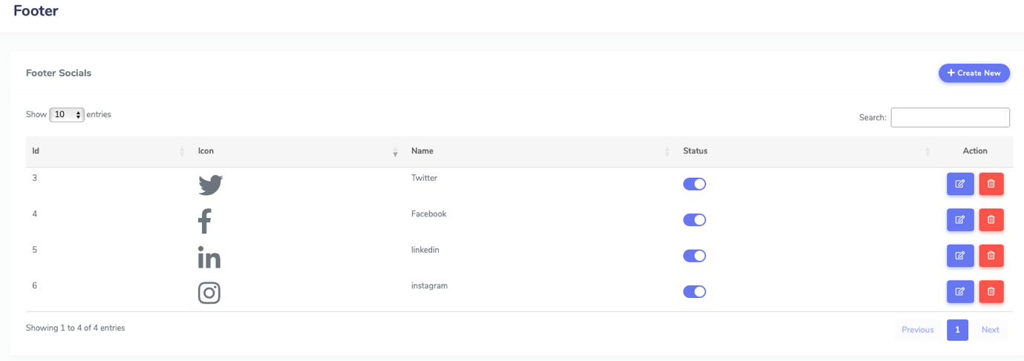

Figure 62

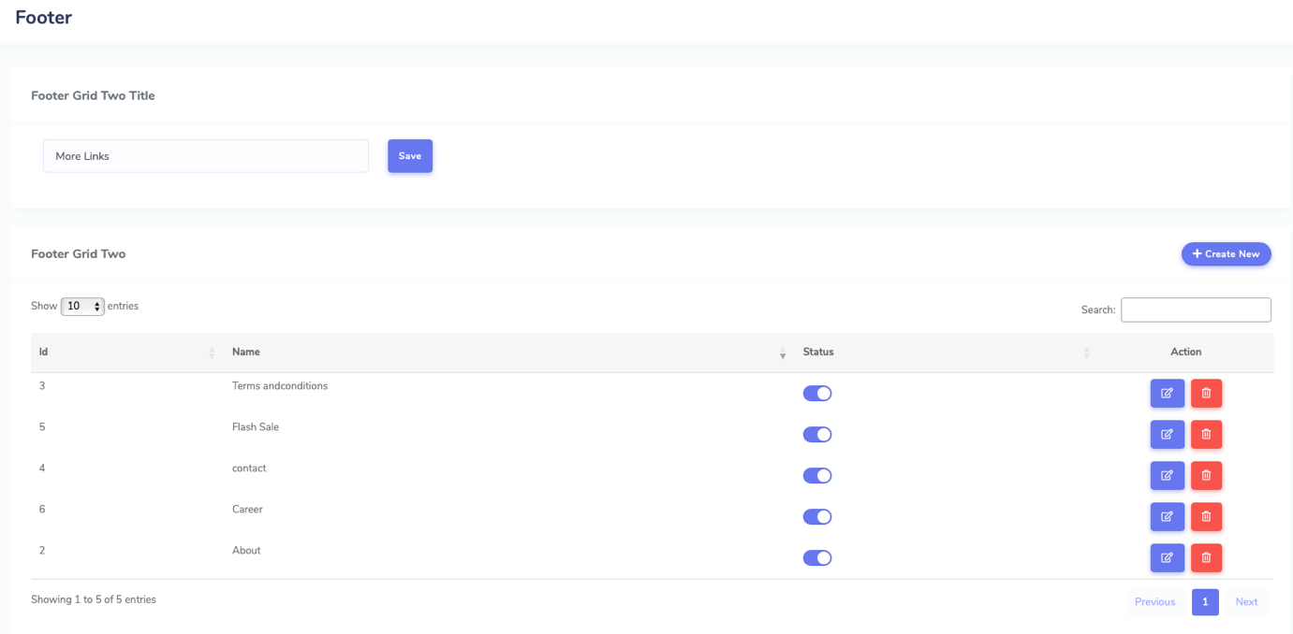

Figure 63

**Admin Dashboard: Users list/s**  
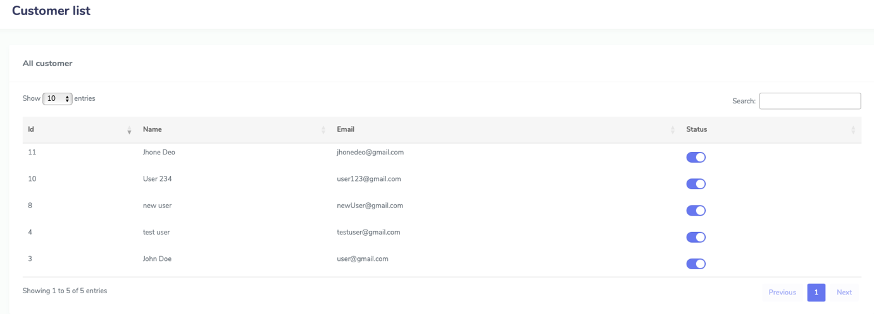

Figure 64

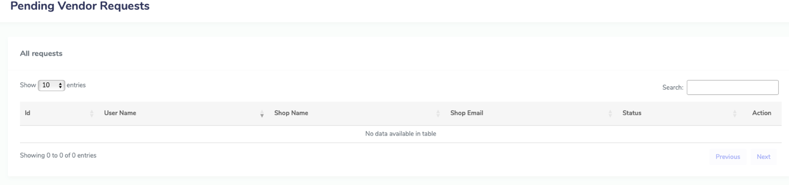

Figure 65

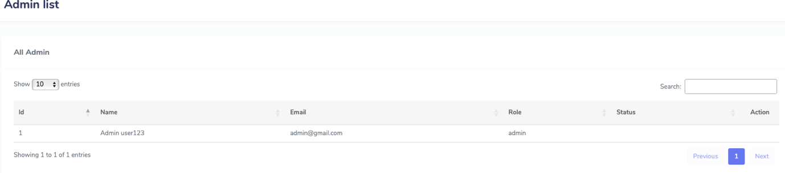

Figure 66

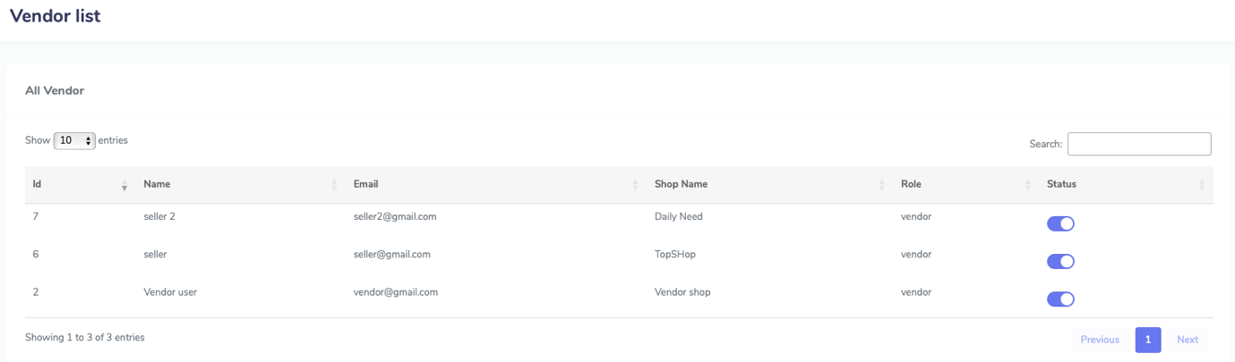

Figure 67

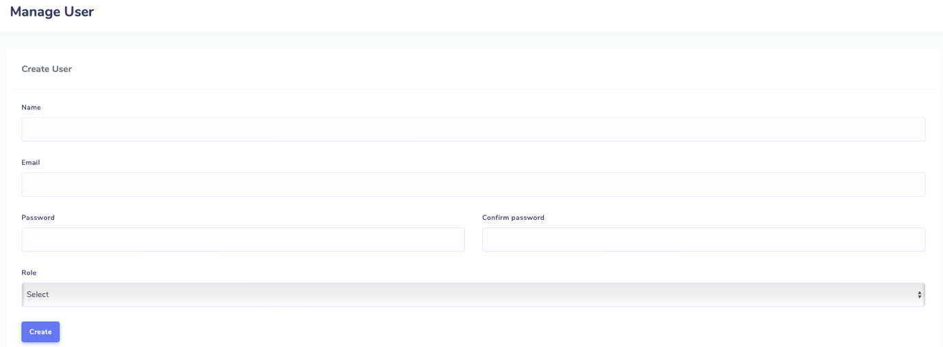

Figure 68

**Admin Dashboard: Send emails to subscribers**  
  
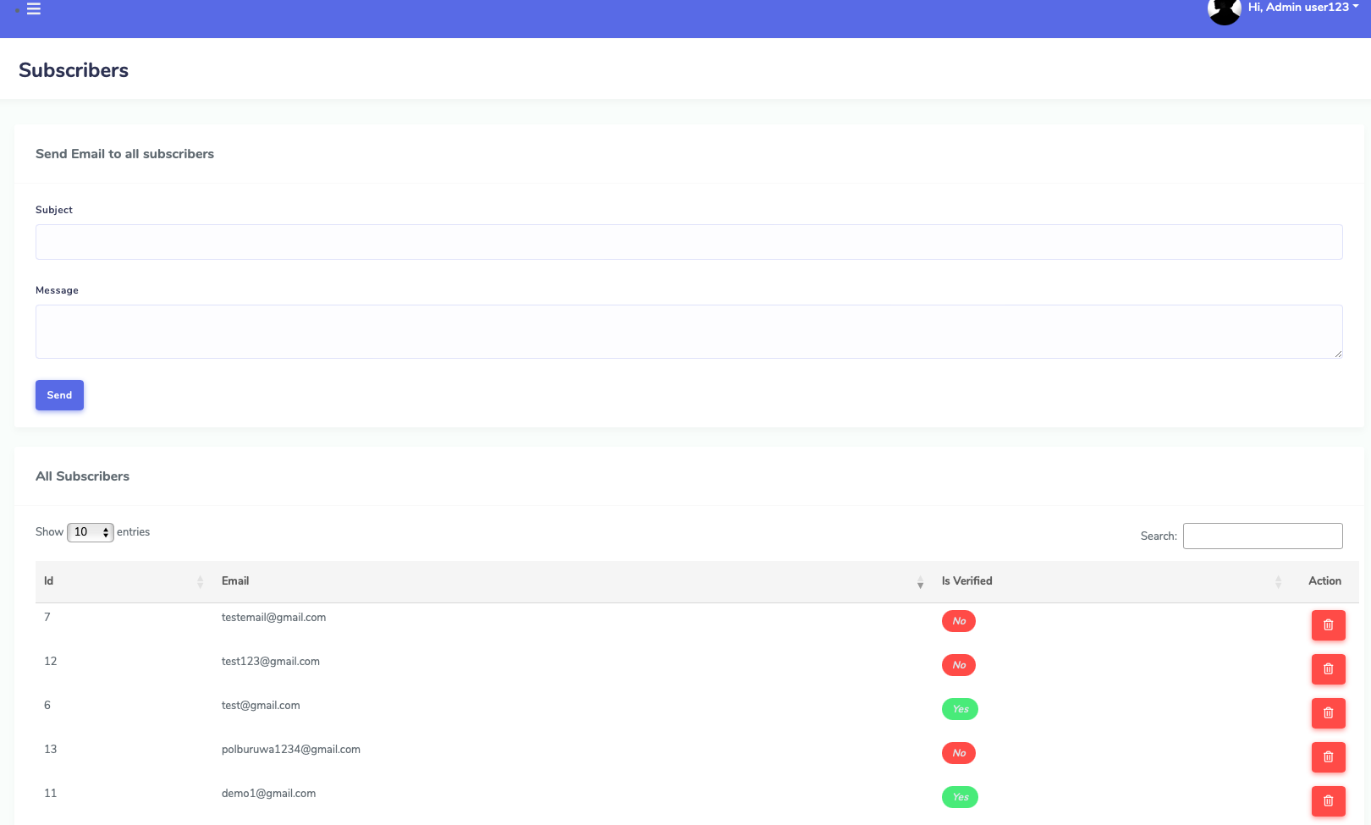

Figure 69

Mail-trap Screenshots  
  
Admin sending emails to subscribers Mail-trap screenshot (sample is a test email for it)  
  
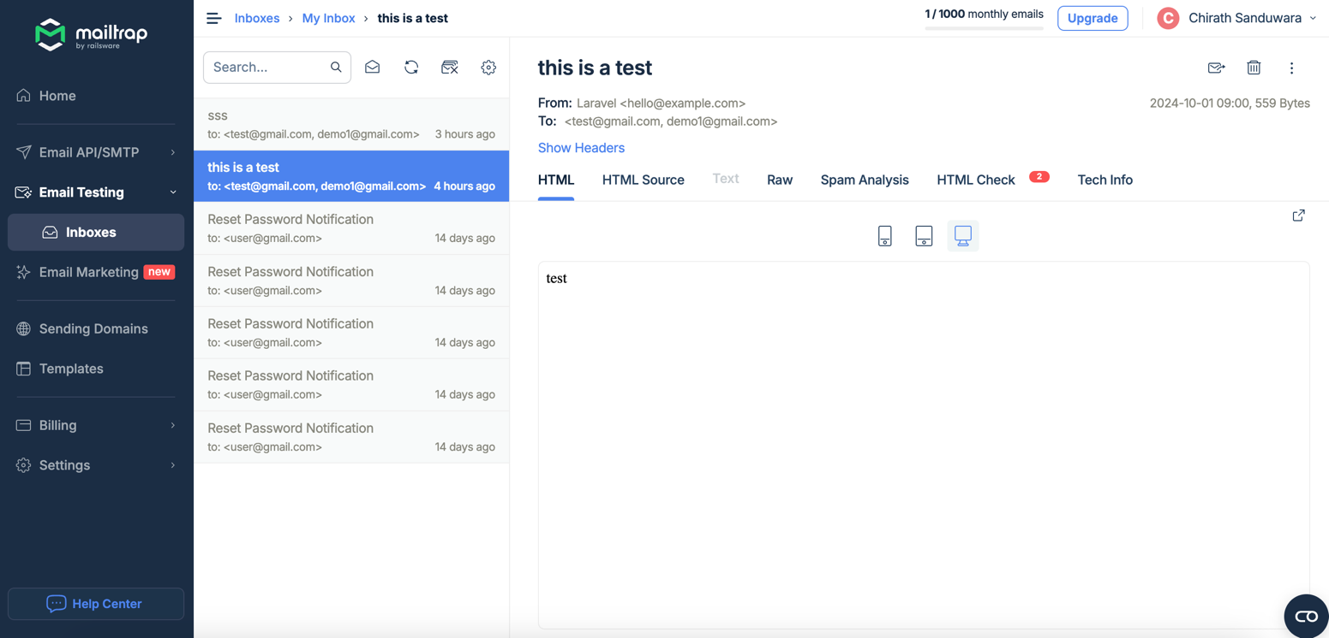

Figure 70

Email verification when signing up Mail-Trap screenshot  
  
  
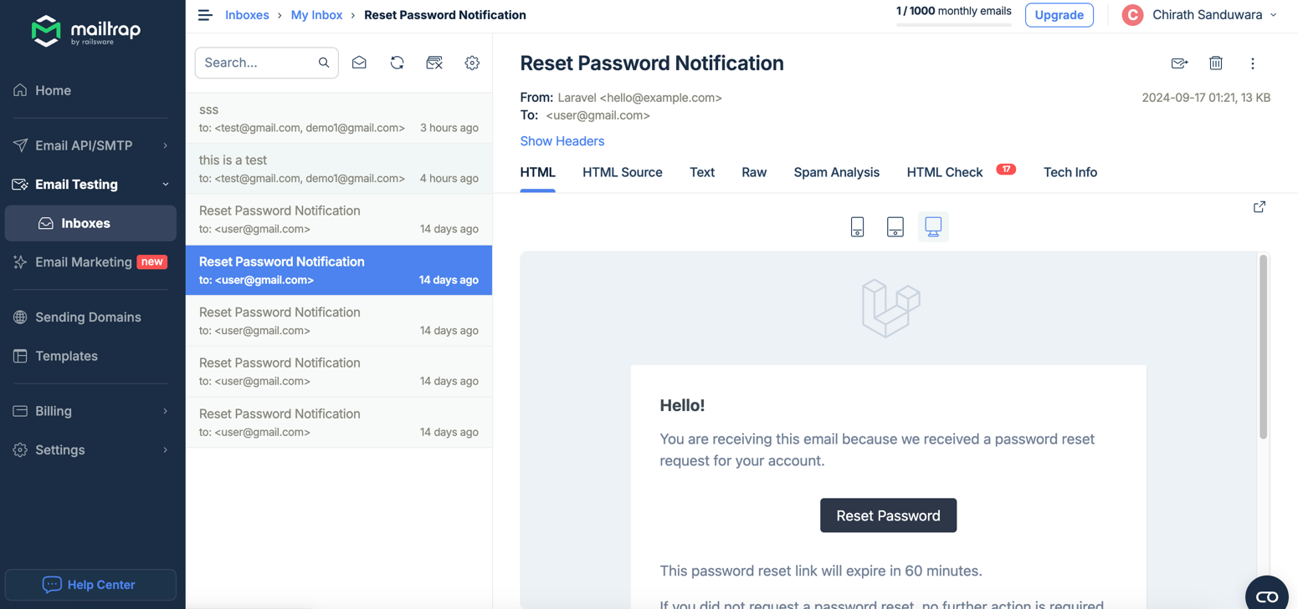

Figure 71

## Screenshots of the code & Postman testing (requests)

**Migration files**  
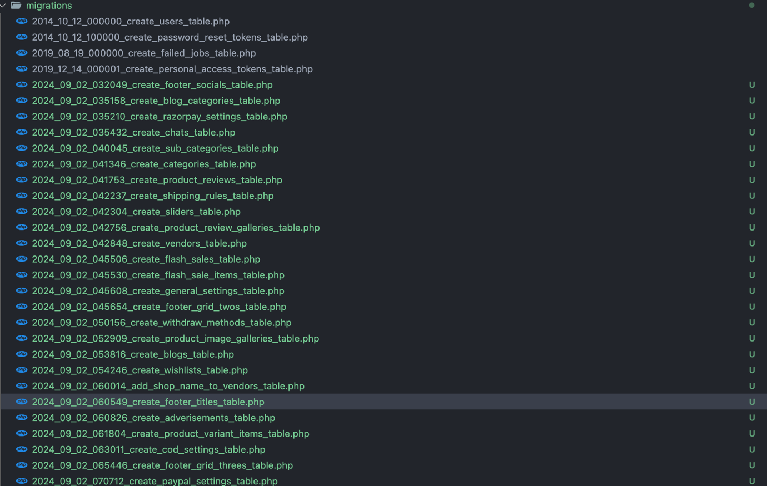

Figure 72

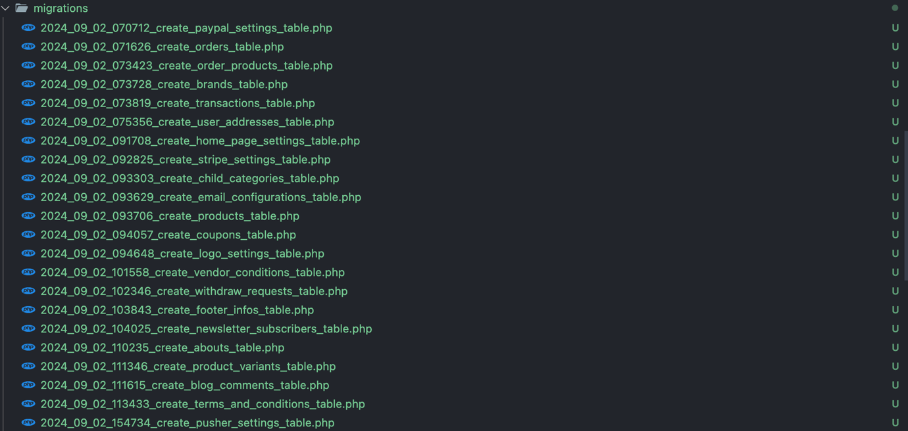

Figure 73

**Some View files**  


Figure 74



Figure 75

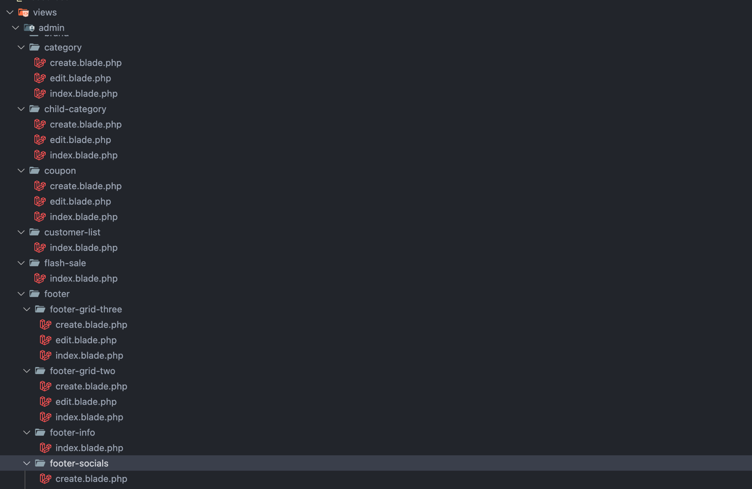

Figure 76

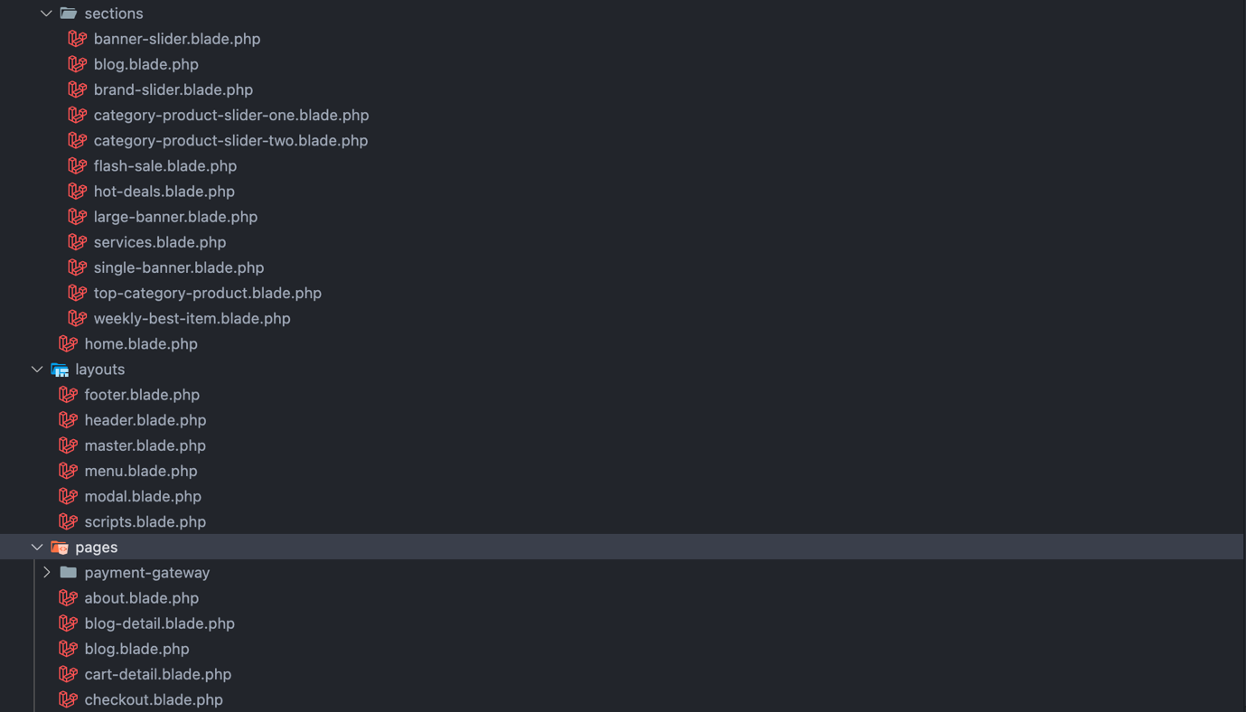

Figure 77

**Controllers  
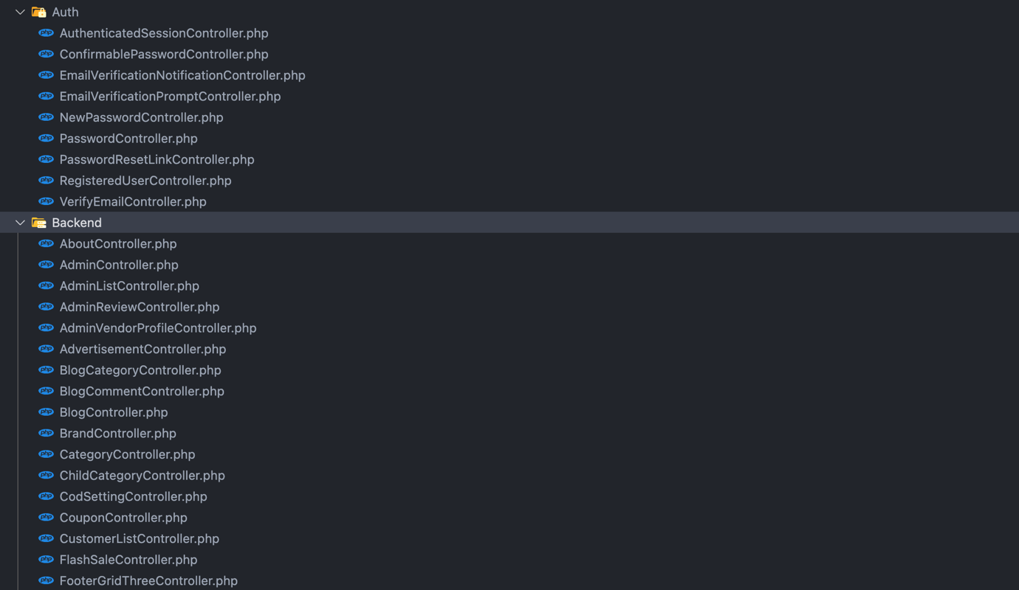**

Figure 78



Figure 79

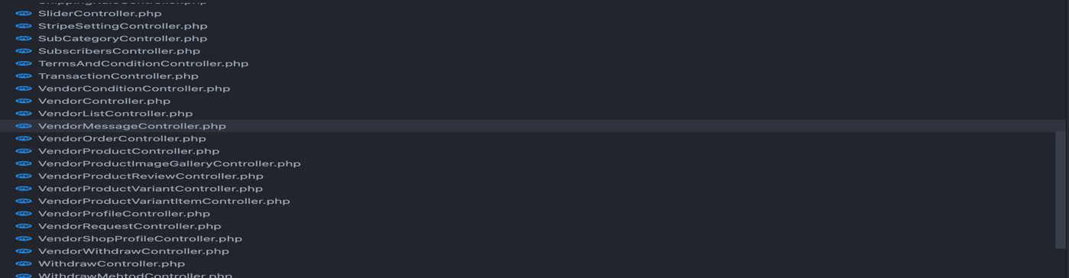

Figure 80

**Middleware  
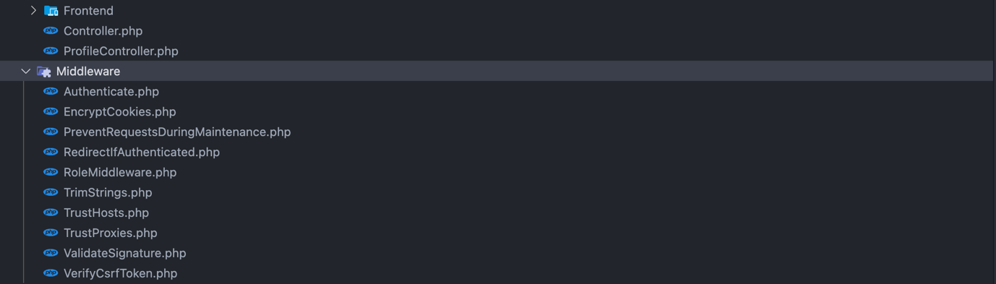**

Figure 81

**Models  
**

Figure 82

**Routes and Some examples  
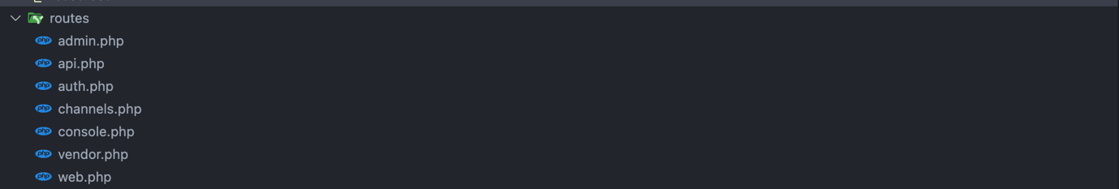**

Figure 83

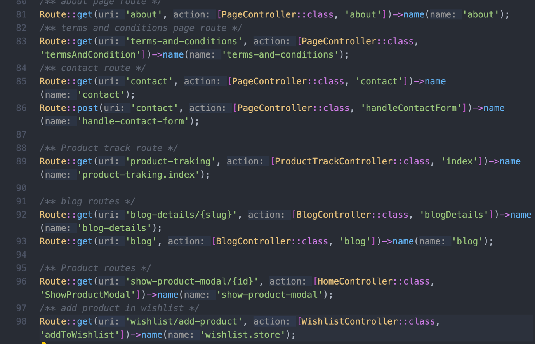

Figure 84

**Admin Controller  
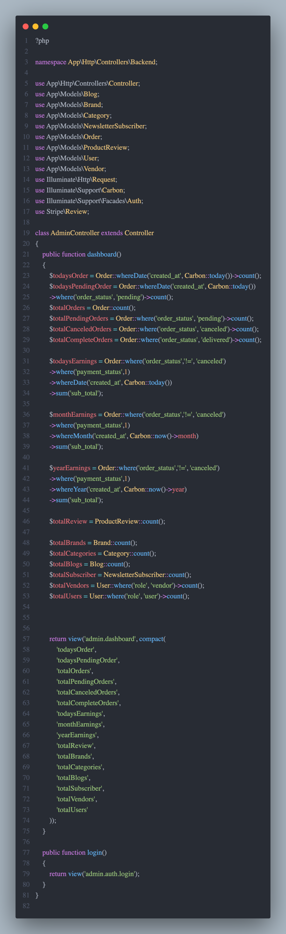**

Figure 85

**Route Files(admin.php | web.php)  
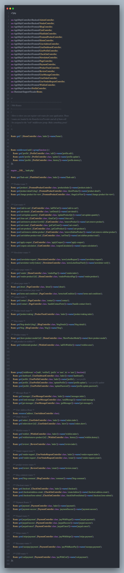**

Figure 86

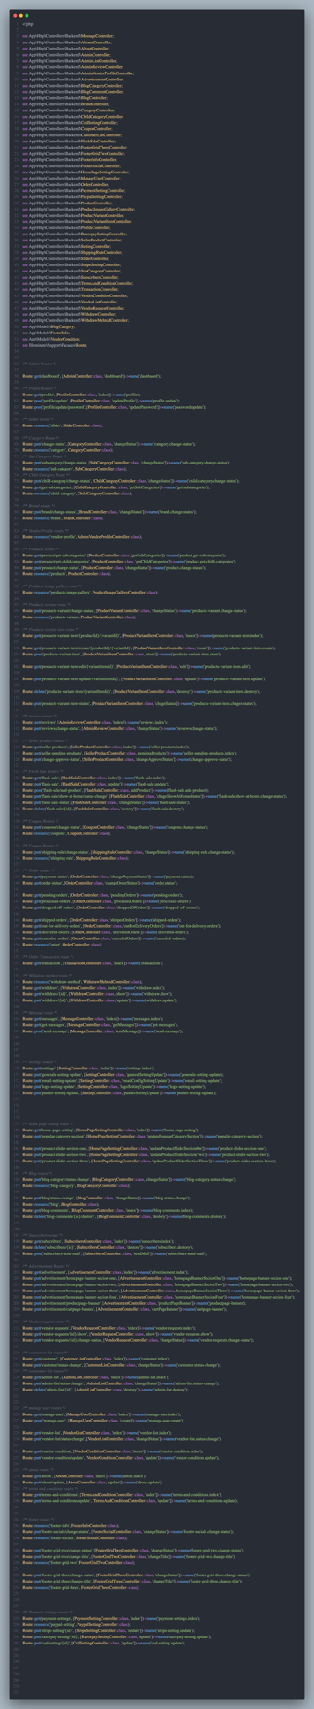

Figure 87

**Lighthouse testing (homepage)**

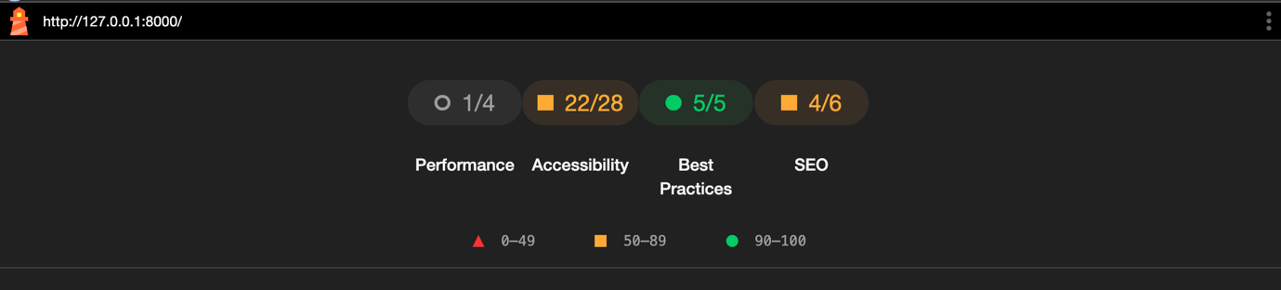

Figure 88

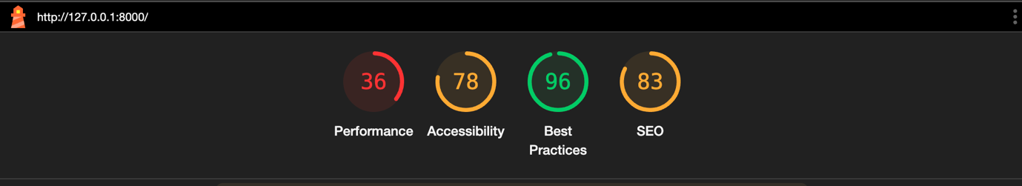

Figure 89

**Lighthouse testing (admin dashboard)  
  
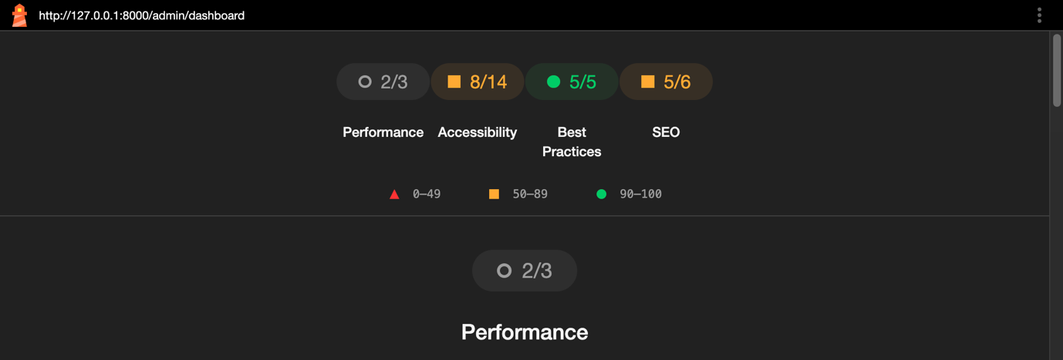**

Figure 90

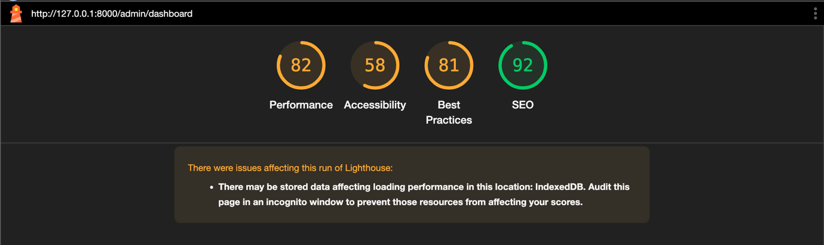

Figure 91

## Test Cases

|  |  |  |  |  |  |
| --- | --- | --- | --- | --- | --- |
| Test Case  ID | Description | Input | Expected Output | Actual Output | Result |
| T01 | User Proceeding with an order | Pressing the checkout button | Order must be displayed on the admin dashboard and the user dashboard | Order was displayed on the admin dashboard and the user dashboard | Pass |
| T02 | Registering an account on the platform | Name: null  Email: null  Password: null  Confirm Password: null | Toastr must show default validations “ Email field is required”  “Password field is required” “Name field is required” | Toastr shows default validations “ Email field is required”  “Password field is required” “Name field is required” | Pass |
| T03 | Printing a receipt of the order details | go to the user dashboard “orders” section and print the order details using the ‘print’ button | Print function pops up with the details of the print | Print function popped up with the details of the print | Pass |
| T04 | Admin adding a product through the dashboard, and it appears on the admin vendor shop frontend | Admin logs in to their respective dashboard and goes to the product category section and adds a new product under a category | The products need to appear on the admin shop’s frontend of the website | The products appeared on the frontend of the website | Pass |
| T05 | Admin deletes a product through the dashboard, and it disappears from the admin shop frontend of the website | Admin logs in to their respective dashboard and goes to the product category section and deletes a product under a category | The products need to disappear from the admin shop’s frontend of the website | The products disappeared from the admin shop’s frontend of the website | Pass |
| T06 | Checking if the chat Api is working | User logs into their dashboard and sends a message to one seller (vendor) | The seller (vendor) must receive the message that the user sent | The seller (vendor) receives the message that the user sent | Pass |
| T07 | Checking if the add to Wishlist function is working | User hovers their pointer towards a product and clicks on the wish-list icon when it pops up | the item must be added to the users Wishlist | the item was added to the Wishlist | Pass |
| T08 | Checking if the newsletter service is working (checking if the users are appearing as subscribers) | Users goes to the bottom of the website and inputs their email to the “subscribe to the newsletter” section | Admin must be able to retrieve the Users that have signed up to the newsletter from the admin dashboard’s “subscribers” section | Admin was able to retrieve the Users that have signed up to the newsletter from the admin dashboard’s “subscribers” section | Pass |
| T09 | Checking if the newsletter service is working (checking if the message that the admin sends to the subscriber is appearing on the mail trap inbox or not) | Admin logs in to the admin dashboard and goes to the “subscribers” section and sends a message to the newsletter subscribers a | The message should be delivered on to the Mail-Trap inbox | The message was delivered to the Mail-Trap inbox | Pass |
| T10 | Checking if the site-wide search function is working | Search “Asus” on the search bar | All the “Asus” products should be displayed | All the “Asus” products were displayed | Pass |

## Assumptions

To develop this website, the assumption was made that the store is located in one location since this is an online only platform

### Future Upgrade Plan

several areas were identified as areas with potential to upgrade in this site,  
  
**1. Subscription Service:**The already implemented subscription service can be improved upon with integrating it into products as well and not just a newsletter service

**Objective:** Introduce recurring revenue by offering subscription-based products (e.g., monthly boxes, service subscriptions, etc.).

**Key Features:**

**Subscription Plans:** Allow users to subscribe to products or services on a recurring basis (e.g., monthly, quarterly).

**Auto-Renewal & Cancellation**: Provide automatic subscription renewal, with an option for users to cancel or pause their subscription.

**Discounts for Subscribers:** Offer discounts and special perks for users who subscribe to products or services.

**Technical Requirements:**

Create new subscriptions table to manage subscription plans and users.

Implement a payment system for recurring billing (e.g., Stripe, PayPal).

Add UI components for users to manage their subscriptions (e.g., pause, cancel, or update).

**2. Search and filter service:**  
  
The already implemented site-wide subscription service can be improved upon with integrating it with artificial intelligence.

**Objective:** Improve the search experience with an intelligent search and filtering system that better understands user intent.  
  
**Key Features:**

**Natural Language Processing (NLP):** Enhance search functionality using NLP to understand user queries more accurately.

**Voice Search:** Integrate voice search for users who prefer voice commands over typing.

**Smart Filters:** Automatically suggest filters based on search queries (e.g., size, brand, price).

**Technical Requirements:**

Integrate an AI-powered search solution like Elasticsearch or Algolia for fast and intelligent results.

Use pre-built NLP models or frameworks (e.g., Google NLP, OpenAI) to enhance search functionality.

Enhance product search performance by optimizing database queries and caching search results.  
  
**3. Loyalty Program and rewards system**

A loyalty program can be implemented to the site. Points can be awarded for every purchase been made through the site, users can be allowed to get discounts using those loyalty points whenever they are purchasing a product again

**Objective:** Increase customer retention by offering a loyalty program with points and rewards for frequent shoppers.

Key Features:

**Points System:** Customers earn points for every purchase, which can be redeemed for discounts or rewards.

**Tiered Rewards:** Offer different reward levels based on customer spending or engagement (e.g., silver, gold, platinum tiers).

**Referral Program:** Allow users to refer friends and earn points or discounts when the referred user makes a purchase.

**Technical Requirements:**

Create new loyalty points and rewards tables to manage user points and reward tiers.

Integrate the loyalty system into the existing user accounts and shopping cart flow.

Build a referral tracking system linked to user accounts.

## Expanding as a SaaS Solution

Expanding the Cloth-X e-commerce platform into a SaaS (Software as a Service) solution offers a scalable business model that allows other businesses to use this platform. Here are the three key points I was considering:

**1. Multi-Tenant Architecture**

Objective: Implement a multi-tenant architecture where multiple businesses can host their e-commerce stores on the same platform, but each business operates independently with its own data and configurations.

**Technical Features:**

Separate databases or logically segmented data for each tenant.

Tenant-specific customization options (e.g., themes, payment gateways, shipping methods).

Role-based access control for store owners and their employees.

**2. Self-Service Onboarding & Store Customization**

Objective: Provide an intuitive onboarding process that allows businesses to easily set up their online stores with minimal technical assistance.

**Key Features:**

Step-by-step store creation wizard, guiding users through adding products, configuring payment/shipping, and setting up storefront designs.

Drag-and-drop website builder with customizable templates for non-technical users.

Integration with popular third-party services (e.g., payment processors, shipping providers) to simplify the setup process.

**3. Subscription Plans & Tiered Pricing**

**Objective:** Create flexible subscription models with tiered pricing to accommodate businesses of different sizes and needs.

**Key Features:**

Offer basic, premium, and enterprise-level plans with varying features (e.g., product limits, transaction fees, support levels).

Implement usage-based pricing for additional services like storage, bandwidth, or advanced analytics.

Automated billing system for managing subscription payments and upgrades.